**A Project Report**

on

**THE PERIODIC TABLE**

For

**CBSE Examination (2016-17)**

[As a part of the **Informatics Practices** Course (065)]

**SUBMITTED BY**

**Rajat Agrawal**

School Roll no. - 7

Exam Roll no. -

**UNDER THE GUIDANCE OF**

**Mrs. Madhu Lekhwani**

PGT (Computer Science)



**SILVER OAK SCHOOL**

CERTIFICATE

This is to certify that the Project entitled **The Periodic Table** is a bonafide work done by **Rajat Agrawal** of **Class XII - Science** Session 2016-17 in partial fulfillment of CBSE **Examination 2016-17** and has been carried out under my direct supervision and guidance. This report or a similar report on the topic has not been submitted for any other examination and does not form a part of any other course undergone by the candidate.

Teacher’s Signature Principal’s Signature Examiner’s Signature

…………………………… …………………………….. ………………………………

Acknowledgement

I

undertook this Project work, as the part of my XII-Informatics Practices course. I had tried to apply my best of knowledge and experience, gained during the study and class work experience. However, developing software system is generally a quite complex and time-consuming process. It requires a systematic study, insight vision and professional approach during the design and development. Moreover, the developer always feels the need, the help and good wishes of the people near you, who have considerable experience and idea.

I would like to extend my sincere thanks and gratitude to my teacher **Mrs. Madhu Lekhwani ma’am.** I am very much thankful to our Principal **Mrs. Runa Banerjee** ma’am and our Vice Principal **Mr. Surendra Yadav** sir for giving valuable time and moral support to develop this software.

I would like to take the opportunity to extend my sincere thanks and gratitude to my family for being a source of inspiration and providing time and freedom to develop this software project.

I also feel indebted to my friends **Mr. Divyansh Jain** and **Mr. Anurag Gupta** for the valuable suggestions during the project work.

**Rajat Agrawal**

**Class XII Science**

Contents

1**. Introduction**

**2. Objective & Scope of the Project**

**3. Theoretical Background**

**4. Problem Definition & Analysis**

**5. System Implementation**

6.1 The Hardware used:

6.2 The Softwares used:

**6. System Design & Development**

7.2 Database Design:

7.3 Form Designs of Different Elements:

7.4 I/O Forms Design & Event Coding:

**7. User Manual**

8.1 How to install:

8.2 Working with Software:

**8. References**

Introduction

This software project is developed to get access to the basic fundamentals of the elements in a periodic table .The purpose of the software project is to develop a basic knowledge of the elements in the periodic table with a special feature of comparison where the user can compare one elements with the other elements. This program deals with the individual information of all the 118 elements in the periodic table.

The Periodic Table mainly consists of a computerized database, a collection of inter-related tables consisting of some physical and chemical values of the elements for the user to compare. An application program is tied with the database for easy access and interface to the database. Using Application program or front-end we can get access to the information about any elements in an interactive manner.

This software, being simple in design and working, does not require much of training to users, and can be used as a powerful tool for getting a review over the periodic table.

During coding and design of the software Project, Java NetBeans IDE, a powerful front-end tool is used for getting Graphical User Interface (GUI) based integrated platform and coding simplicity. As a back-end a powerful, open source RDBMS, My SQL is used as per requirement of the CBSE curriculum of Informatics Practices Course.

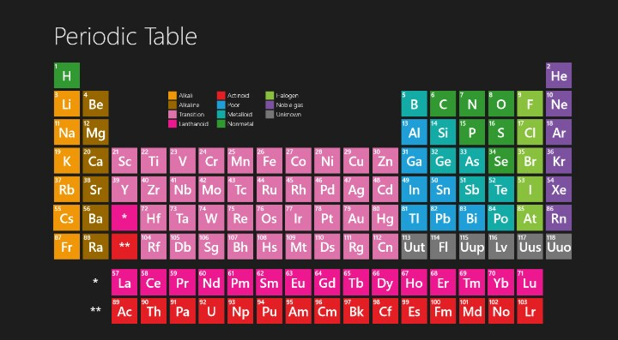

Objective and scope of the project

T

he objective of the software project is to develop a computerized program for a review over the elements in the periodic table. This software project is also aimed to the convenience of the users as they sometimes need to compare one element with another element in different aspects.

The proposed software system is expected to do the following functionality-

* To provide a user friendly, Graphical User Interface (GUI) based integrated and centralized environment for a periodic table.
* The proposed system should contain all the basic informations regarding the elements of a periodic table.
* To provide graphical and user-friendly interface to interact with a centralized database based on client-server architecture.
* To compare the elements of the periodic table by the critical operation procedure and possibilities of simplification using modern IT tools and practices.

In its current scope, the software enables user to retrieve and update the information from centralized database designed with MySQL. This software does not require much training time of the users due to limited functionality and simplicity.

During the development of The Periodic Table, Java NetBeans IDE, a powerful, open source event-driven form-based development environment is used for modular design and future expandability of the system.

So far as future scope of the project is concerned, firstly it is open to any modular expansion i.e. other modules or functions can be designed and embedded to handle the user need in future. Any part of the software and reports can be modified independently without much effort.

Theoretical background

## 

## What is Database?

### Introduction and Concepts:

A database is a collection of information related to a particular subject or purpose, such as tracking customer orders or maintaining a music collection. Using any RDBMS application software like MS SQL Server, MySQL, Oracle, Sybase etc, you can manage all your information from a single database file. Within the file, divide your data into separate storage containers called tables. You may and retrieve the data using queries.

A table is a collection of data about a specific topic, such as products or suppliers. Using a separate table for each topic means you can store that data only once, which makes your database more efficient and reduces data-entry errors. Table organises data into columns (called fields) and rows (called records).

A Primary key is one or more fields whose value or values uniquely identify each record in a table. In a relationship, a primary key is used to refer to specific record in one table from another table. A primary key is called foreign key when it is referred to from another table.

To find and retrieve just the data that meets conditions you specify, including data from multiple tables, create a query. A query can also update or delete multiple records at the same time, and perform built-in or custom calculations on your data.

### Role of RDBMS Application Program:

A computer database works as a electronic filing system, which has a large number of ways of cross-referencing, and this allows the user many different ways in which to re-organize and retrieve data. A database can handle business inventory, accounting and filing and use the information in its files to prepare summaries, estimates and other reports. The management of data in a database system is done by means of a general-purpose software package called a Database Management System (DBMS). Some commercially available DBMS are MS SQL Server, MS ACCESS, INGRES, ORACLE, and Sybase. A database management system, therefore, is a combination of hardware and software that can be used to set up and monitor a database, and can manage the updating and retrieval of database that has been stored in it. Most of the database management systems have the following capabilities:

* Creating of a table, addition, deletion, modification of records.
* Retrieving data collectively or selectively.
* The data stored can be sorted or indexed at the user's discretion and direction.
* Various reports can be produced from the system. These may be either standardized report or that may be specifically generated according to specific user definition.
* Mathematical functions can be performed and the data stored in the database can be manipulated with these functions to perform the desired calculations.
* To maintain data integrity and database use.

The DBMS interprets and processes users' requests to retrieve information from a database. In most cases, a query request will have to penetrate several layers of software in the DBMS and operating system before the physical database can be accessed. The DBMS responds to a query by invoking the appropriate subprograms, each of which performs its special function to interpret the query, or to locate the desired data in the database and present it in the desired order.

## What is My SQL? logo-mysql

The management of data in a database system is done by means of a general-purpose software package called a Database Management System (DBMS). Some commercially available RDBMS are MS SQL Server, MS ACCESS, INGRES, ORACLE, and Sybase.

MySQL, the most popular Open Source SQL database management system, is developed, distributed, and supported by Oracle Corporation. MySQL is named after co-founder Monty Widenius's daughter, My. The name of the MySQL Dolphin (our logo) is “Sakila”.

* **MySQL is a database management system.**

A database is a structured collection of data. It may be anything from a simple shopping list to a picture gallery or the vast amounts of information in a corporate network. To add, access, and process data stored in a computer database, you need a database management system such as MySQL Server. Since computers are very good at handling large amounts of data, database management systems play a central role in computing, as standalone utilities, or as parts of other applications.

* **MySQL is based on SQL.**

A relational database stores data in separate tables rather than putting all the data in one big storeroom. This adds speed and flexibility. The SQL part of “MySQL” stands for “Structured Query Language.” SQL is the most common standardized language used to access databases and is defined by the ANSI/ISO SQL Standard. The SQL standard has been evolving since 1986 and several versions exist. In this manual, “SQL-92” refers to the standard released in 1992, “SQL:1999” refers to the standard released in 1999, and “SQL:2003” refers to the current version of the standard.

* **MySQL software is Open Source.**

Open Source means that it is possible for anyone to use and modify the software. Anybody can download the MySQL software from the Internet and use it without paying anything. If you wish, you may study the source code and change it to suit your needs. The MySQL software uses the GPL (GNU General Public License),

* **The MySQL Database Server is very fast, reliable, and easy to use.**

If that is what you are looking for, you should give it a try. MySQL Server also has a practical set of features developed in close cooperation with our users. You can find a performance comparison of MySQL Server with other database managers on our benchmark page. MySQL Server was originally developed to handle large databases much faster than existing solutions and has been successfully used in highly demanding production environments for several years. Although under constant development, MySQL Server today offers a rich and useful set of functions. Its connectivity, speed, and security make MySQL Server highly suited for accessing databases on the Internet.

* **MySQL Server works in client/server or embedded systems.**

The MySQL Database Software is a client/server system that consists of a multi-threaded SQL server that supports different backends, several different client programs and libraries, administrative tools, and a wide range of application programming interfaces (APIs).

**The Main Features of MySQL**

* Written in C and C++.
* Works on many different platforms.
* Uses multi-layered server design with independent modules.
* Provides transactional and nontransactional storage engines.
* Designed to make it relatively easy to add other storage engines. This is useful if you want to provide an SQL interface for an in-house database.
* Uses a very fast thread-based memory allocation system.
* Executes very fast joins using an optimized nested-loop join.
* Implements SQL functions using a highly optimized class library that should be as fast as possible. Usually there is no memory allocation at all after query initialization.
* Provides the server as a separate program for use in a client/server networked environment, and as a library that can be embedded (linked) into standalone applications. Such applications can be used in isolation or in environments where no network is available.
* Password security by encryption of all password traffic when you connect to a server.
* Support for large databases. We use MySQL Server with databases that contain 50 million records. We also know of users who use MySQL Server with 200,000 tables and about 5,000,000,000 rows.
* MySQL client programs can be written in many languages. A client library written in C is available for clients written in C or C++, or for any language that provides C bindings.
* APIs for C, C++, Eiffel, Java, Perl, PHP, Python, Ruby, and Tcl are available, enabling MySQL clients to be written in many languages.
* The Connector/ODBC (MyODBC) interface provides MySQL support for client programs that use ODBC (Open Database Connectivity) connections.
* The Connector/J interface provides MySQL support for Java client programs that use JDBC connections. Clients can be run on Windows or Unix. Connector/J source is available.

## What is NetBeans IDE ?

NetBeans started as a student project (originally called Xelfi) in the Czech Republic in 1996. The goal was to write a Delphi-like Java IDE in Java. Xelfi was the first Java IDE (Integrated Development Environment) written in Java, with its first pre-releases in 1997. Xelfi was a fun project to work on, especially since Java IDE space was uncharted territory at that time. The project attracted enough interest that these students, once they graduated, decided that they could market it as a commercial product. Soliciting resources from friends and relatives for a web space, they formed a company around it.

Soon after, they were contacted by [Roman Stanek](http://www.google.com/search?q=roman+stanek&hl=en&lr=&c2coff=1&client=safari&rls=en&start=10&sa=N), an entrepreneur who had already been involved in several startups in the Czech Republic. He was looking for a good idea to invest in, and discovered Xelfi. He met with the founders; they hit it off, and a business was born.

In the spring of 1999, [NetBeans DeveloperX2](http://www.internetnews.com/dev-news/article.php/75561) was released, supporting Swing. The performance improvements that came in JDK 1.3, released in the fall of 1999, made NetBeans a viable choice for development tools. By the summer of 1999, the team was hard at work re-architecting DeveloperX2 into the more modular NetBeans that forms the basis of the software today.

Something else was afoot in the summer of 1999: [Sun Microsystems](http://www.sun.com) wanted better Java development tools, and had become interested in NetBeans. It was a dream come true for the NetBeans team: NetBeans would become the flagship tool set of the maker of Java itself! By the Fall, with the next generation of NetBeans Developer in beta, a deal was struck. Sun Microsystems had also acquired another tools company, During the acqusition, the young developers who had been involved in open-source projects for most of their programming careers, mentioned the idea of open-sourcing NetBeans. Fast forward to less than six months later, the decision was made that NetBeans would be open sourced. While Sun had contributed considerable amounts of code to open source projects over the years, this was Sun's first *sponsored* open source project, one in which Sun would be paying for the site and handling the infrastructure.

# Features of NetBeans

A free, open-source Integrated Development Environment for software developers. You get all the tools you need to create professional desktop, enterprise, web, and mobile applications with the Java platform, as well as C/C++, PHP, JavaScript, Groovy, and Ruby.

NetBeans IDE 6.9 introduces the JavaFX Composer, support for JavaFX SDK 1.3, OSGi interoperability, support for the PHP Zend framework and Ruby on Rails 3.0, and more.

Problem definition and analysis

The hardest part of building a software system is deciding precisely what to build. No other part of the conceptual work is so difficult as establishing the detailed technical requirement. Defining and applying good, complete requirements are hard to work, and success in this endeavor has eluded many of us. Yet, we continue to make progress.

Problem definition describes the *What* of a system, not *How* . The quality of a software product is only as good as the process that creates it. Problem definition is one of the most crucial steps in this creation process. Without defining a problem, developers do not know what to build, customers do not know what to expect, and there is no way to validate that the built system satisfies the requirement.

Problem definition and Analysis is the activity that encompasses learning about the problem to be solved, understanding the needs of customer and users, trying to find out who the user really is, and understanding all the constraints on the solution. It includes all activities related to the following:

* Identification and documentation of customer’s or user’s needs.
* Creation of a document that describes the external behavior and the association constraints that will satisfies those needs.
* Analysis and validation of the requirements documents to ensure consistency, completeness, and feasibility
* Evolution of needs.

After the analysis of the functioning of a Public Library system, the proposed System is expected to do the following: -

* To provide a user friendly, Graphical User Interface (GUI) based integrated and centralized environment for a periodic table.
* The proposed system should contain all the basic informations regarding the elements of a periodic table.
* To provide graphical and user-friendly interface to interact with a centralized database based on client-server architecture.
* To compare the elements of the periodic table by the critical operation procedure and possibilities of simplification using modern IT tools and practices.

System implementation

## The Hardware used:

While developing the system, the used hardware are:

PC with Pentium CPU G2030 processor @ 3.00 GHz having 2.00 GB RAM and system being 32-bit operating system, SVGA and other required devices.

## The Software used:

* Microsoft Windows 7 Ultimate as Operating System.
* Java NetBeans 8.1 as Front-end Development environment.
* MySQL as Back-end Sever with Database for Testing.
* MS-Word 2007 for documentation.

System design and development

## 

## Database Design:

An important aspect of system design is the design of data storage structure. To begin with a logical model of data structure is developed first. A database is a container object which contains tables, queries, reports and data validation policies enforcement rules or contraints etc. A logical data often represented as a records are kept in different tables after reducing anomalies and redundancies. The goodness of data base design lies in the table structure and its relationship.

This software project maintains a database named **Periodic** which contains the following table.

### Table Design:

The database of Periodic contains only one table named **Elements**. The tables are normalized to minimize the redundancies of data and enforcing the validation rules of the organization. Most of the tables are designed to store master records. The table and its structure is given below.

**Table: Elements**

|  |  |  |
| --- | --- | --- |
| COLUMN NAME | TYPE | SIZE |
| Atomic_number | Integer | 3 |
| Element_name | Varchar | 30 |
| Atomic_mass | Double | 7 |
| Density | Double | 6 |
| Melting_point | Double | 6 |
| Boiling_point | Double | 6 |
| Electronegativity | Double | 3 |

The table used in the database is given below:

|  |  |  |  |  |  |  |
| --- | --- | --- | --- | --- | --- | --- |
| Atomic_  number | Element_name | Atomic_  mass | Density | Melting_  point | Boiling_  point | Electro  negativity |
|  |  |  |  |  |  |  |
| 1 | [Hydrogen](https://en.wikipedia.org/wiki/Hydrogen) | 1.008 | 0.0000 | 14.01 | 20.28 | 2.20 |
| 2 | [Helium](https://en.wikipedia.org/wiki/Helium) | 4.0026 | 0.0001 | 0.95 | 4.22 | NULL |
| 3 | [Lithium](https://en.wikipedia.org/wiki/Lithium) | 6.94 | 0.534 | 453.69 | 1560 | 0.98 |
| 4 | [Beryllium](https://en.wikipedia.org/wiki/Beryllium) | 9.0121 | 1.85 | 1560 | 2742 | 1.57 |
| 5 | [Boron](https://en.wikipedia.org/wiki/Boron) | 10.81 | 2.34 | 2349 | 4200 | 2.04 |
| 6 | [Carbon](https://en.wikipedia.org/wiki/Carbon) | 12.011 | 2.267 | 3800 | 4300 | 2.55 |
| 7 | [Nitrogen](https://en.wikipedia.org/wiki/Nitrogen) | 14.007 | 0.0012 | 63.15 | 77.36 | 3.04 |
| 8 | [Oxygen](https://en.wikipedia.org/wiki/Oxygen) | 15.999 | 0.0014 | 54.36 | 90.20 | 3.44 |
| 9 | [Fluorine](https://en.wikipedia.org/wiki/Fluorine) | 18.9984 | 0.0016 | 53.53 | 85.03 | 3.98 |
| 10 | [Neon](https://en.wikipedia.org/wiki/Neon) | 20.1797 | 0.0008 | 24.56 | 27.07 | NULL |
| 11 | [Sodium](https://en.wikipedia.org/wiki/Sodium) | 22.9897 | 0.971 | 370.87 | 1156 | 0.93 |
| 12 | [Magnesium](https://en.wikipedia.org/wiki/Magnesium) | 24.305 | 1.738 | 923 | 1363 | 1.31 |
| 13 | [Aluminium](https://en.wikipedia.org/wiki/Aluminium) | 26.9815 | 2.698 | 933.47 | 2792 | 1.61 |
| 14 | [Silicon](https://en.wikipedia.org/wiki/Silicon) | 28.085 | 2.3296 | 1687 | 3538 | 1.9 |
| 15 | [Phosphorus](https://en.wikipedia.org/wiki/Phosphorus) | 30.9737 | 1.82 | 317.30 | 550 | 2.19 |
| 16 | [Sulfur](https://en.wikipedia.org/wiki/Sulfur) | 32.06 | 2.067 | 388.36 | 717.87 | 2.58 |
| 17 | [Chlorine](https://en.wikipedia.org/wiki/Chlorine) | 35.45 | 0.0032 | 171.6 | 239.11 | 3.16 |
| 18 | [Argon](https://en.wikipedia.org/wiki/Argon) | 39.948 | 0.0017 | 83.80 | 87.30 | NULL |
| 19 | [Potassium](https://en.wikipedia.org/wiki/Potassium) | 39.0983 | 0.862 | 336.53 | 1032 | 0.82 |
| 20 | [Calcium](https://en.wikipedia.org/wiki/Calcium) | 40.078 | 1.54 | 1115 | 1757 | 1 |
| 21 | [Scandium](https://en.wikipedia.org/wiki/Scandium) | 44.9559 | 2.989 | 1814 | 3109 | 1.36 |
| 22 | [Titanium](https://en.wikipedia.org/wiki/Titanium) | 47.867 | 4.54 | 1941 | 3560 | 1.54 |
| 23 | [Vanadium](https://en.wikipedia.org/wiki/Vanadium) | 50.9415 | 6.11 | 2183 | 3680 | 1.63 |
| 24 | [Chromium](https://en.wikipedia.org/wiki/Chromium) | 51.9961 | 7.15 | 2180 | 2944 | 1.66 |
| 25 | [Manganese](https://en.wikipedia.org/wiki/Manganese) | 54.9380 | 7.44 | 1519 | 2334 | 1.55 |
| 26 | [Iron](https://en.wikipedia.org/wiki/Iron) | 55.845 | 7.874 | 1811 | 3134 | 1.83 |
| 27 | [Cobalt](https://en.wikipedia.org/wiki/Cobalt) | 58.9331 | 8.86 | 1768 | 3200 | 1.88 |
| 28 | [Nickel](https://en.wikipedia.org/wiki/Nickel) | 58.6934 | 8.912 | 1728 | 3186 | 1.91 |
| 29 | [Copper](https://en.wikipedia.org/wiki/Copper) | 63.546 | 8.96 | 1357.77 | 2835 | 1.9 |
| 30 | [Zinc](https://en.wikipedia.org/wiki/Zinc) | 65.38 | 7.134 | 692.88 | 1180 | 1.65 |
| 31 | [Gallium](https://en.wikipedia.org/wiki/Gallium) | 69.723 | 5.907 | 302.914 | 2477 | 1.81 |
| 32 | [Germanium](https://en.wikipedia.org/wiki/Germanium) | 72.630 | 5.323 | 1211.40 | 3106 | 2.01 |
| 33 | [Arsenic](https://en.wikipedia.org/wiki/Arsenic) | 74.921 | 5.776 | 1090 | 887 | 2.18 |
| 34 | [Selenium](https://en.wikipedia.org/wiki/Selenium) | 78.971 | 4.809 | 453 | 958 | 2.55 |
| 35 | [Bromine](https://en.wikipedia.org/wiki/Bromine) | 79.904 | 3.122 | 265.8 | 332.0 | 2.96 |
| 36 | [Krypton](https://en.wikipedia.org/wiki/Krypton) | 83.798 | 0.0037 | 115.79 | 119.93 | 3 |
| 37 | [Rubidium](https://en.wikipedia.org/wiki/Rubidium) | 85.4678 | 1.532 | 312.46 | 961 | 0.82 |
| 38 | [Strontium](https://en.wikipedia.org/wiki/Strontium) | 87.62 | 2.64 | 1050 | 1655 | 0.95 |
| 39 | [Yttrium](https://en.wikipedia.org/wiki/Yttrium) | 88.905 | 4.469 | 1799 | 3609 | 1.22 |
| 40 | [Zirconium](https://en.wikipedia.org/wiki/Zirconium) | 91.224 | 6.506 | 2128 | 4682 | 1.33 |
| 41 | [Niobium](https://en.wikipedia.org/wiki/Niobium) | 92.9063 | 8.57 | 2750 | 5017 | 1.6 |
| 42 | [Molybdenum](https://en.wikipedia.org/wiki/Molybdenum) | 95.95 | 10.22 | 2896 | 4912 | 2.16 |
| 43 | [Technetium](https://en.wikipedia.org/wiki/Technetium) | 98 | 11.5 | 2430 | 4538 | 1.9 |
| 44 | [Ruthenium](https://en.wikipedia.org/wiki/Ruthenium) | 101.07 | 12.37 | 2607 | 4423 | 2.2 |
| 45 | [Rhodium](https://en.wikipedia.org/wiki/Rhodium) | 102.9055 | 12.41 | 2237 | 3968 | 2.28 |
| 46 | [Palladium](https://en.wikipedia.org/wiki/Palladium) | 106.42 | 12.02 | 1828.05 | 3236 | 2.2 |
| 47 | [Silver](https://en.wikipedia.org/wiki/Silver) | 107.868 | 10.501 | 1234.93 | 2435 | 1.93 |
| 48 | [Cadmium](https://en.wikipedia.org/wiki/Cadmium) | 112.414 | 8.69 | 594.22 | 1040 | 1.69 |
| 49 | [Indium](https://en.wikipedia.org/wiki/Indium) | 114.818 | 7.31 | 429.75 | 2345 | 1.78 |
| 50 | [Tin](https://en.wikipedia.org/wiki/Tin) | 118.710 | 7.287 | 505.08 | 2875 | 1.96 |
| 51 | [Antimony](https://en.wikipedia.org/wiki/Antimony) | 121.760 | 6.685 | 903.78 | 1860 | 2.05 |
| 52 | [Tellurium](https://en.wikipedia.org/wiki/Tellurium) | 127.60 | 6.232 | 722.66 | 1261 | 2.1 |
| 53 | [Iodine](https://en.wikipedia.org/wiki/Iodine) | 126.9044 | 4.93 | 386.85 | 457.4 | 2.66 |
| 54 | [Xenon](https://en.wikipedia.org/wiki/Xenon) | 131.293 | 0.0058 | 161.4 | 165.03 | 2.6 |
| 55 | [Caesium](https://en.wikipedia.org/wiki/Caesium) | 132.90545 | 1.873 | 301.59 | 944 | 0.79 |
| 56 | [Barium](https://en.wikipedia.org/wiki/Barium) | 137.327 | 3.594 | 1000 | 2170 | 0.89 |
| 57 | [Lanthanum](https://en.wikipedia.org/wiki/Lanthanum) | 138.9054 | 6.145 | 1193 | 3737 | 1.1 |
| 58 | [Cerium](https://en.wikipedia.org/wiki/Cerium) | 140.116 | 6.77 | 1068 | 3716 | 1.12 |
| 59 | [Praseodymium](https://en.wikipedia.org/wiki/Praseodymium) | 140.9076 | 6.773 | 1208 | 3793 | 1.13 |
| 60 | [Neodymium](https://en.wikipedia.org/wiki/Neodymium) | 144.242 | 7.007 | 1297 | 3347 | 1.14 |
| 61 | [Promethium](https://en.wikipedia.org/wiki/Promethium) | 145 | 7.26 | 1315 | 3273 | 1.13 |
| 62 | [Samarium](https://en.wikipedia.org/wiki/Samarium) | 150.36 | 7.52 | 1345 | 2067 | 1.17 |
| 63 | [Europium](https://en.wikipedia.org/wiki/Europium) | 151.964 | 5.243 | 1099 | 1802 | 1.2 |
| 64 | [Gadolinium](https://en.wikipedia.org/wiki/Gadolinium) | 157.25 | 7.895 | 1585 | 3546 | 1.2 |
| 65 | [Terbium](https://en.wikipedia.org/wiki/Terbium) | 158.9253 | 8.229 | 1629 | 3503 | 1.2 |
| 66 | [Dysprosium](https://en.wikipedia.org/wiki/Dysprosium) | 162.500 | 8.55 | 1680 | 2840 | 1.22 |
| 67 | [Holmium](https://en.wikipedia.org/wiki/Holmium) | 164.9303 | 8.795 | 1734 | 2993 | 1.23 |
| 68 | [Erbium](https://en.wikipedia.org/wiki/Erbium) | 167.259 | 9.066 | 1802 | 3141 | 1.24 |
| 69 | [Thulium](https://en.wikipedia.org/wiki/Thulium) | 168.9342 | 9.321 | 1818 | 2223 | 1.25 |
| 70 | [Ytterbium](https://en.wikipedia.org/wiki/Ytterbium) | 173.045 | 6.965 | 1097 | 1469 | 1.1 |
| 71 | [Lutetium](https://en.wikipedia.org/wiki/Lutetium) | 174.9668 | 9.84 | 1925 | 3675 | 1.27 |
| 72 | [Hafnium](https://en.wikipedia.org/wiki/Hafnium) | 178.49 | 13.31 | 2506 | 4876 | 1.3 |
| 73 | [Tantalum](https://en.wikipedia.org/wiki/Tantalum) | 180.9478 | 16.654 | 3290 | 5731 | 1.5 |
| 74 | [Tungsten](https://en.wikipedia.org/wiki/Tungsten) | 183.84 | 19.25 | 3695 | 5828 | 2.36 |
| 75 | [Rhenium](https://en.wikipedia.org/wiki/Rhenium) | 186.207 | 21.02 | 3459 | 5869 | 1.9 |
| 76 | [Osmium](https://en.wikipedia.org/wiki/Osmium) | 190.23 | 22.61 | 3306 | 5285 | 2.2 |
| 77 | [Iridium](https://en.wikipedia.org/wiki/Iridium) | 192.217 | 22.56 | 2719 | 4701 | 2.2 |
| 78 | [Platinum](https://en.wikipedia.org/wiki/Platinum) | 195.084 | 21.46 | 2041.4 | 4098 | 2.28 |
| 79 | [Gold](https://en.wikipedia.org/wiki/Gold) | 196.9665 | 19.282 | 1337.33 | 3129 | 2.54 |
| 80 | [Mercury](https://en.wikipedia.org/wiki/Mercury_(element)) | 200.592 | 13.5336 | 234.43 | 629.88 | 2 |
| 81 | [Thallium](https://en.wikipedia.org/wiki/Thallium) | 204.38 | 11.85 | 577 | 1746 | 1.62 |
| 82 | [Lead](https://en.wikipedia.org/wiki/Lead) | 207.2 | 11.342 | 600.61 | 2022 | 1.87 |
| 83 | [Bismuth](https://en.wikipedia.org/wiki/Bismuth) | 208.9804 | 9.807 | 544.7 | 1837 | 2.02 |
| 84 | [Polonium](https://en.wikipedia.org/wiki/Polonium) | 209 | 9.32 | 527 | 1235 | 2.0 |
| 85 | [Astatine](https://en.wikipedia.org/wiki/Astatine) | 210 | 7 | 575 | 610 | 2.2 |
| 86 | [Radon](https://en.wikipedia.org/wiki/Radon) | 222 | 0.0097 | 202 | 211.3 | 2.2 |
| 87 | [Francium](https://en.wikipedia.org/wiki/Francium) | 223 | 1.87 | 300 | 950 | 0.7 |
| 88 | [Radium](https://en.wikipedia.org/wiki/Radium) | 226 | 5.5 | 973 | 2010 | 0.9 |
| 89 | [Actinium](https://en.wikipedia.org/wiki/Actinium) | 227 | 10.07 | 1323 | 3471 | 1.1 |
| 90 | [Thorium](https://en.wikipedia.org/wiki/Thorium) | 232.0377 | 11.72 | 2115 | 5061 | 1.3 |
| 91 | [Protactinium](https://en.wikipedia.org/wiki/Protactinium) | 231.0358 | 15.37 | 1841 | 4300 | 1.5 |
| 92 | [Uranium](https://en.wikipedia.org/wiki/Uranium) | 238.0289 | 18.95 | 1405.3 | 4404 | 1.38 |
| 93 | [Neptunium](https://en.wikipedia.org/wiki/Neptunium) | 237 | 20.45 | 917 | 4273 | 1.36 |
| 94 | [Plutonium](https://en.wikipedia.org/wiki/Plutonium) | 244 | 19.84 | 912.5 | 3501 | 1.28 |
| 95 | [Americium](https://en.wikipedia.org/wiki/Americium) | 243 | 13.69 | 1449 | 2880 | 1.13 |
| 96 | [Curium](https://en.wikipedia.org/wiki/Curium) | 247 | 13.51 | 1613 | 3383 | 1.28 |
| 97 | [Berkelium](https://en.wikipedia.org/wiki/Berkelium) | 247 | 14.79 | 1259 | 2900 | 1.3 |
| 98 | [Californium](https://en.wikipedia.org/wiki/Californium) | 251 | 15.1 | 1173 | 1743 | 1.3 |
| 99 | [Einsteinium](https://en.wikipedia.org/wiki/Einsteinium) | 252 | 8.84 | 1133 | 1269 | 1.3 |
| 100 | [Fermium](https://en.wikipedia.org/wiki/Fermium) | 257 | NULL | 1125 | NULL | 1.3 |
| 101 | [Mendelevium](https://en.wikipedia.org/wiki/Mendelevium) | 258 | NULL | 1100 | NULL | 1.3 |
| 102 | [Nobelium](https://en.wikipedia.org/wiki/Nobelium) | 259 | NULL | 1100 | NULL | 1.3 |
| 103 | [Lawrencium](https://en.wikipedia.org/wiki/Lawrencium) | 266 | NULL | 1900 | NULL | 1.3 |
| 104 | [Rutherfordium](https://en.wikipedia.org/wiki/Rutherfordium) | 267 | 23.2 | 2400 | 5800 | NULL |
| 105 | [Dubnium](https://en.wikipedia.org/wiki/Dubnium) | 268 | 29.3 | NULL | NULL | NULL |
| 106 | [Seaborgium](https://en.wikipedia.org/wiki/Seaborgium) | 269 | 35.0 | NULL | NULL | NULL |
| 107 | [Bohrium](https://en.wikipedia.org/wiki/Bohrium) | 270 | 37.1 | NULL | NULL | NULL |
| 108 | [Hassium](https://en.wikipedia.org/wiki/Hassium) | 269 | 40.7 | NULL | NULL | NULL |
| 109 | [Meitnerium](https://en.wikipedia.org/wiki/Meitnerium) | 278 | 37.4 | NULL | NULL | NULL |
| 110 | [Darmstadtium](https://en.wikipedia.org/wiki/Darmstadtium) | 281 | 34.8 | NULL | NULL | NULL |
| 111 | [Roentgenium](https://en.wikipedia.org/wiki/Roentgenium) | 282 | 28.7 | NULL | NULL | NULL |
| 112 | [Copernicium](https://en.wikipedia.org/wiki/Copernicium) | 285 | 23.7 | NULL | 357 | NULL |
| 113 | [Ununtrium](https://en.wikipedia.org/wiki/Ununtrium) | 286 | 16 | 700 | 1400 | NULL |
| 114 | [Flerovium](https://en.wikipedia.org/wiki/Flerovium) | 289 | 14 | 340 | 420 | NULL |
| 115 | [Ununpentium](https://en.wikipedia.org/wiki/Ununpentium) | 289 | 13.5 | 700 | 1400 | NULL |
| 116 | [Livermorium](https://en.wikipedia.org/wiki/Livermorium) | 293 | 12.9 | 708.5 | 1085 | NULL |
| 117 | [Ununseptium](https://en.wikipedia.org/wiki/Ununseptium) | 294 | 7.2 | 723 | 883 | NULL |
| 118 | [Ununoctium](https://en.wikipedia.org/wiki/Ununoctium) | 294 | 5.0 | 258 | 263 | NULL |

## Form Designs of Different Elements:

There are **118 forms** of elements in the program. These are connected to the Main Page of our program.

These forms get open on by clicking on their respective element’s symbol. We can return back to our main page by clicking on the ‘Okay’ button attached with each frame below.

The various forms are given below.

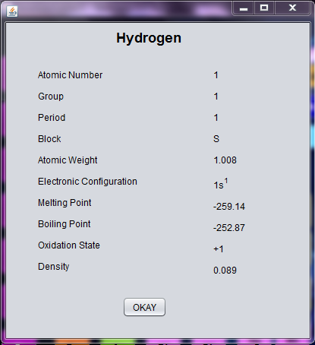 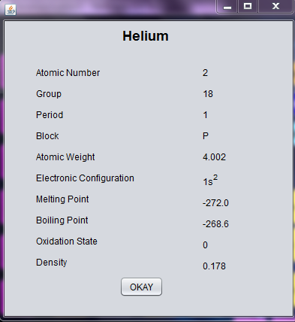

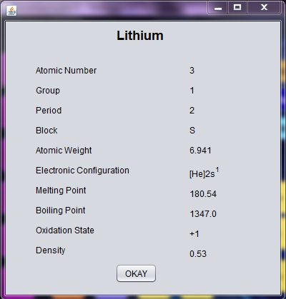 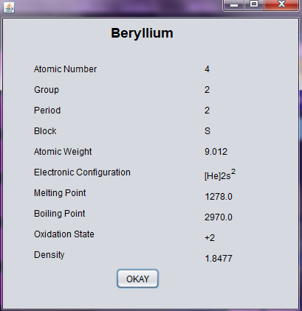

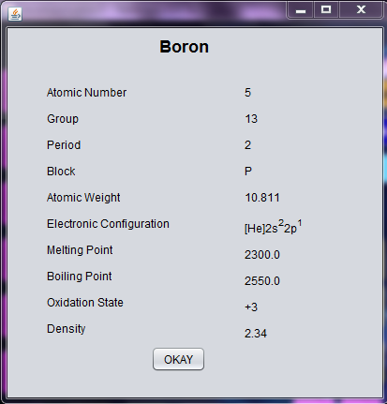 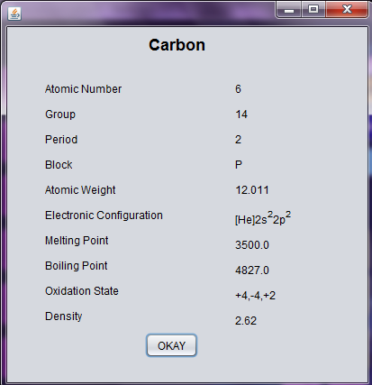

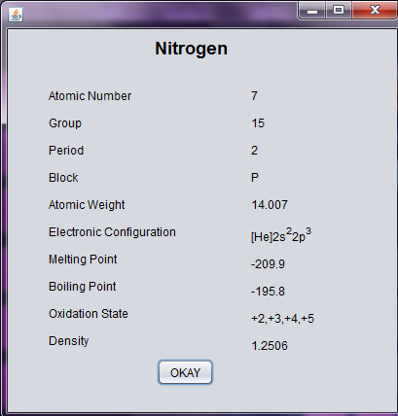 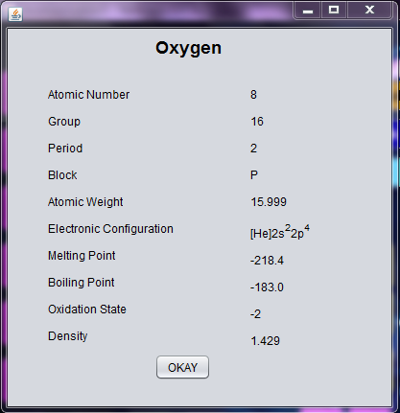

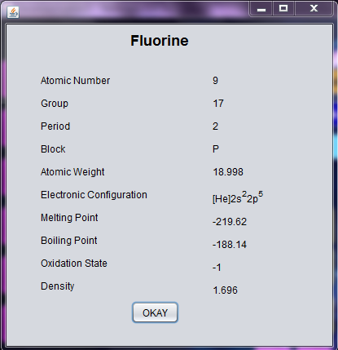 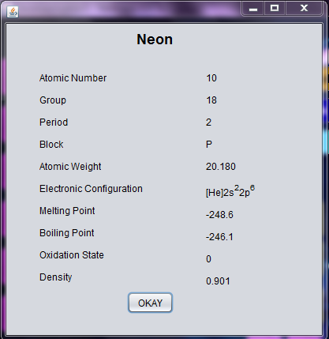

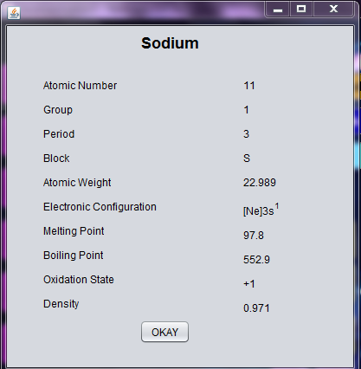 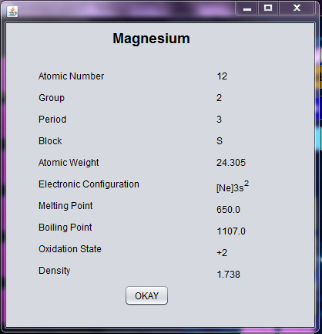

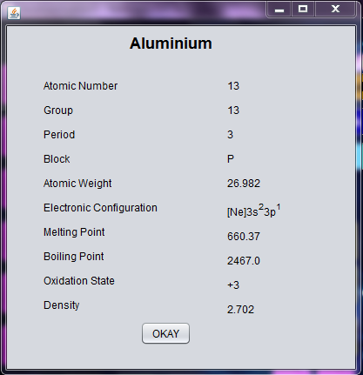 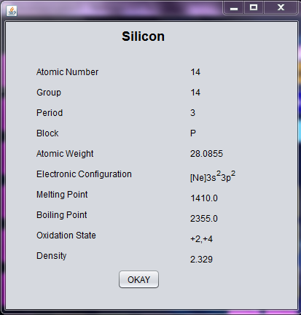

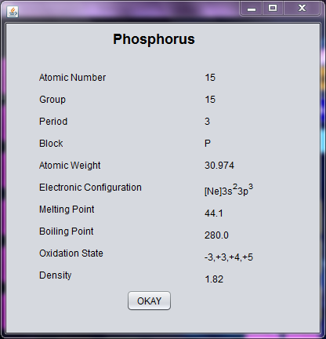 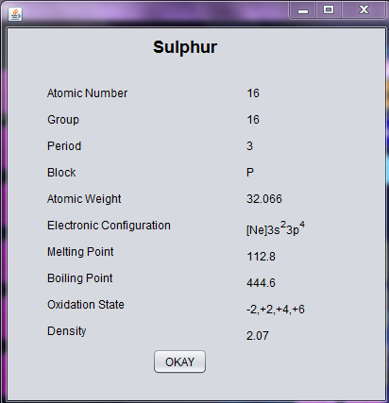

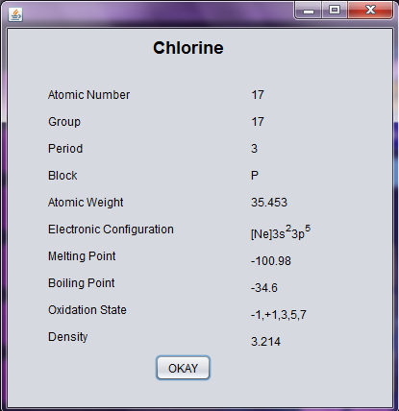 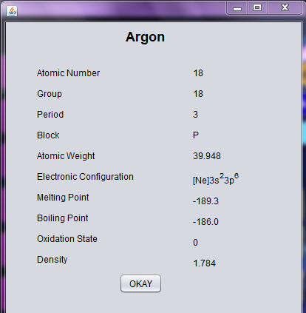

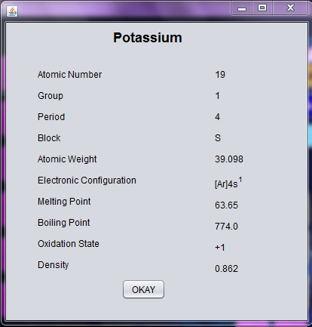 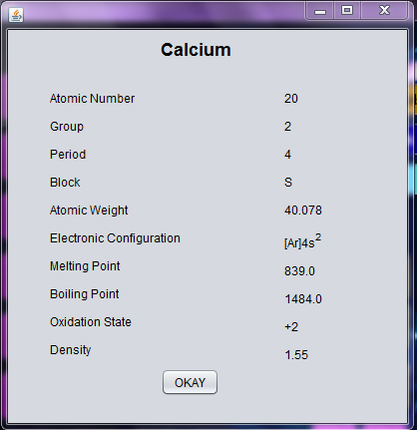

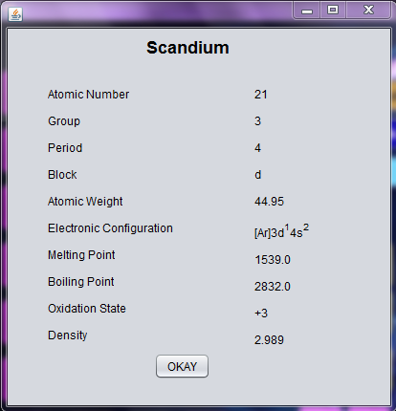 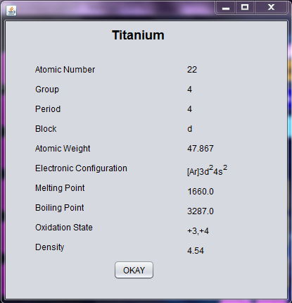

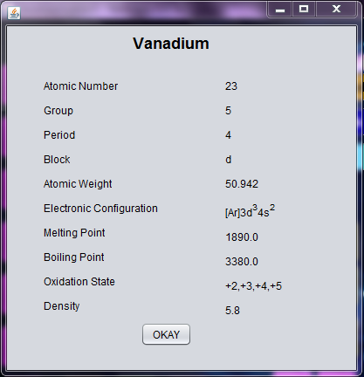 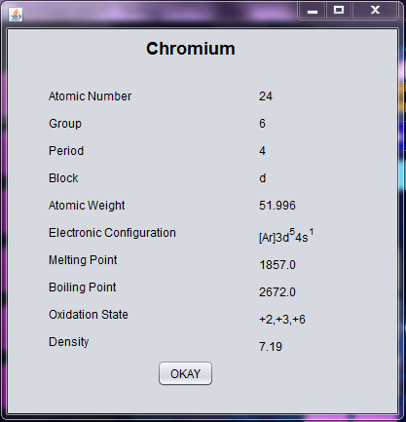

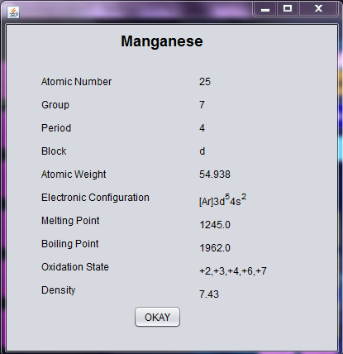 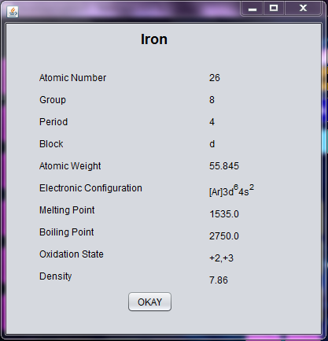

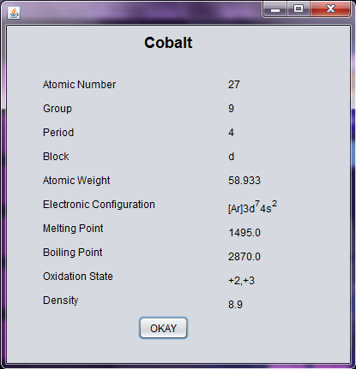 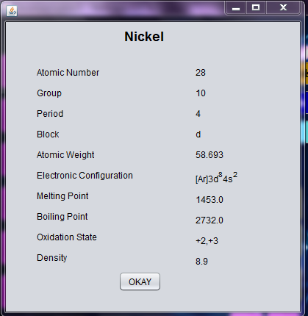

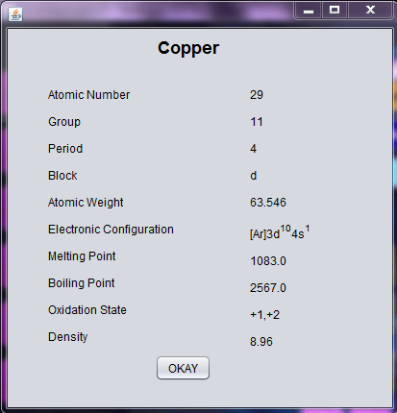 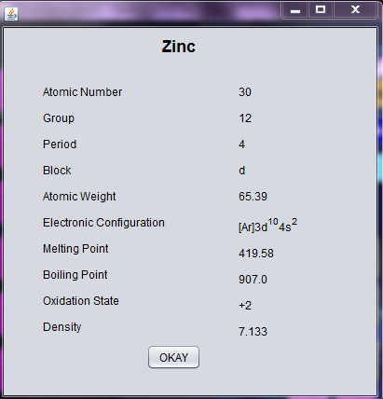

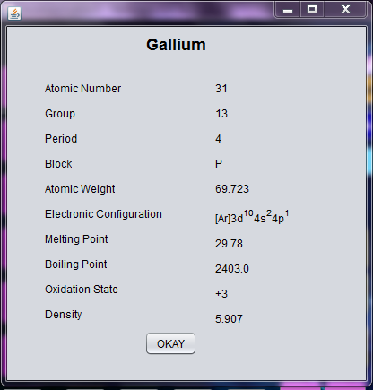 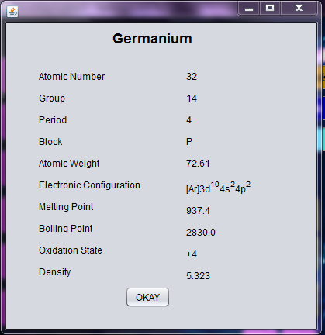

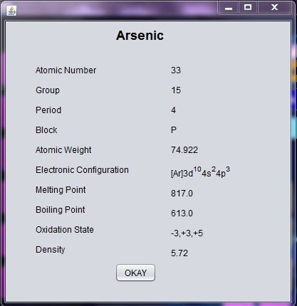 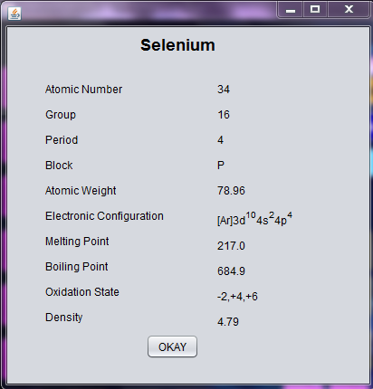

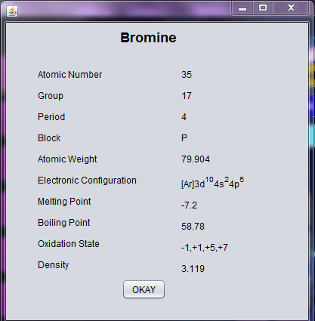 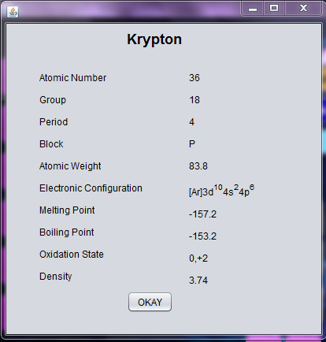

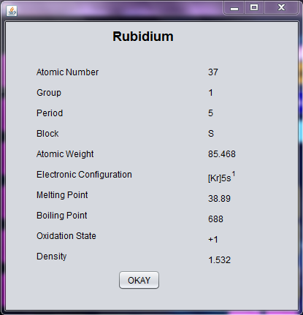 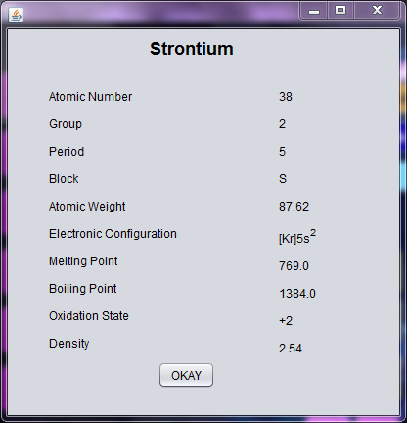

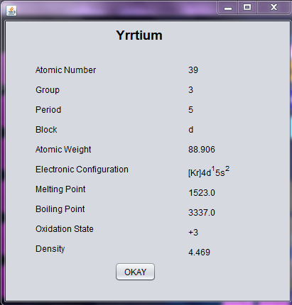 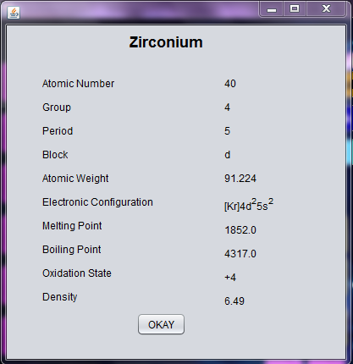

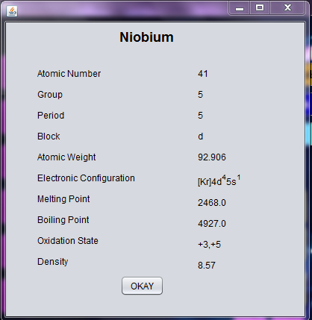 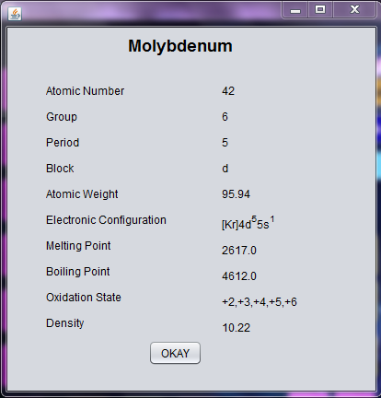

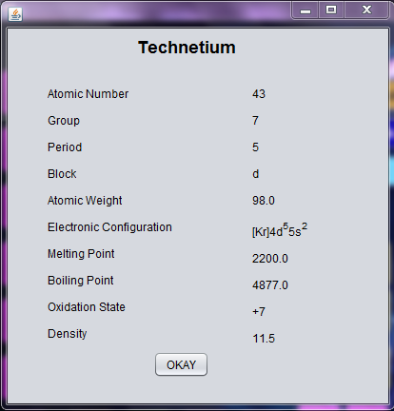 

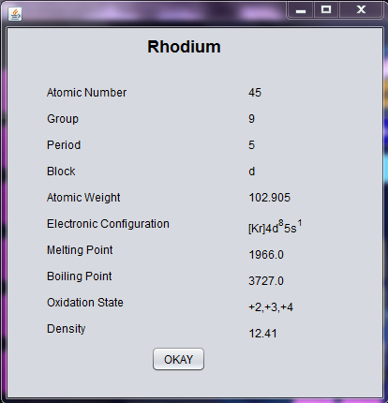 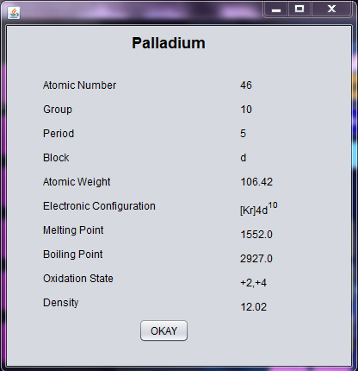

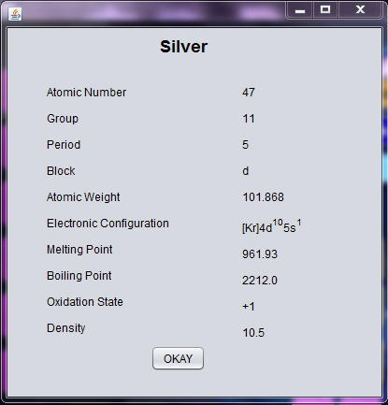 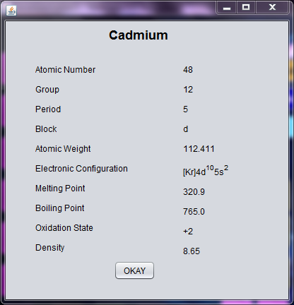

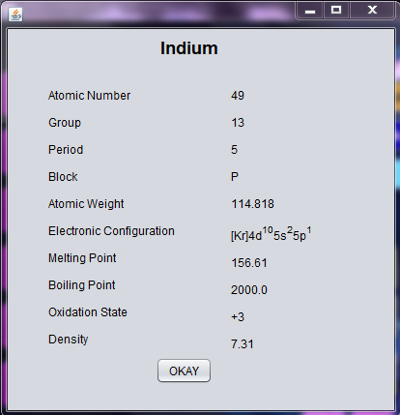 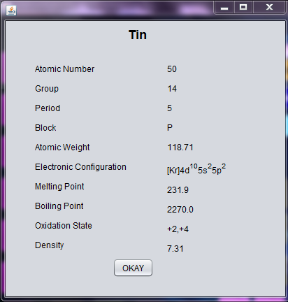

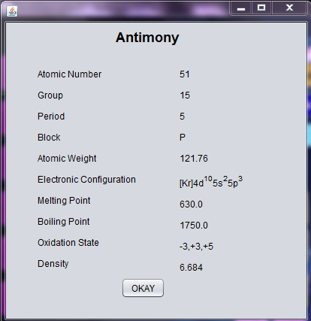 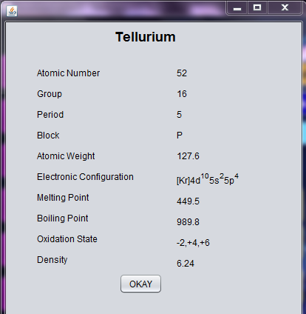

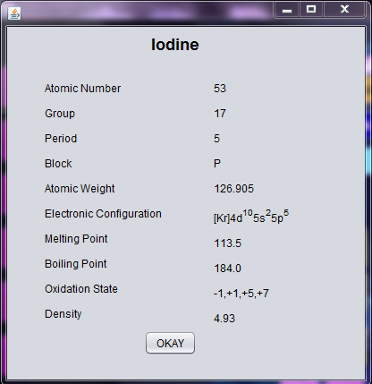 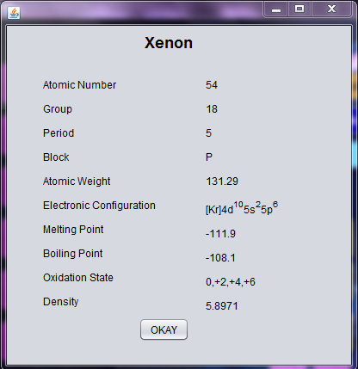

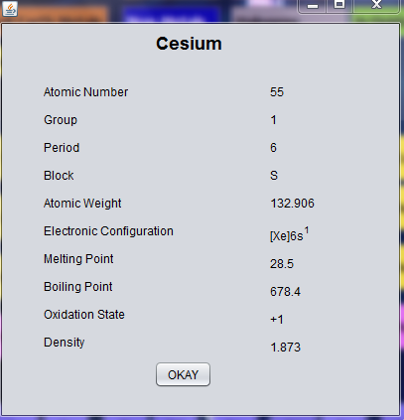 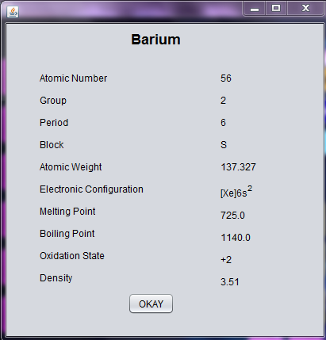

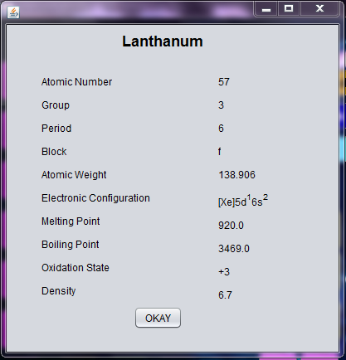 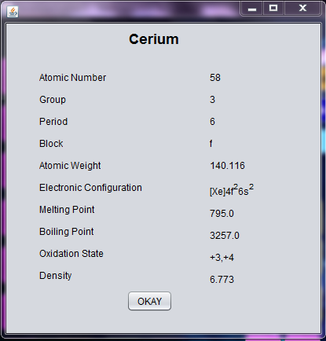

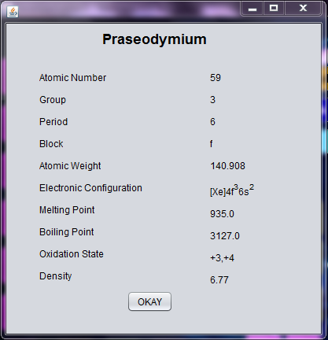 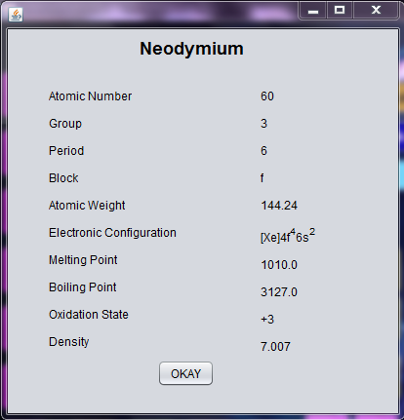

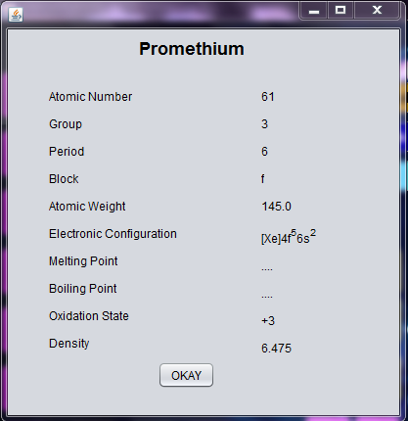 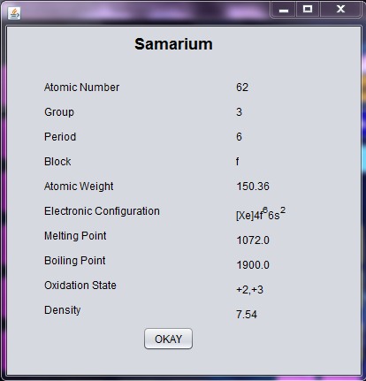

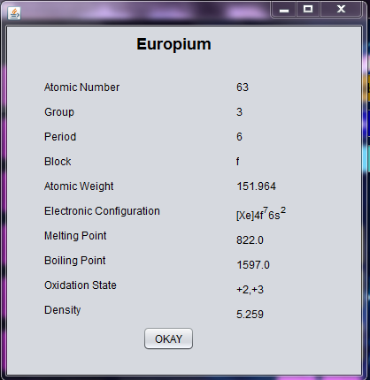 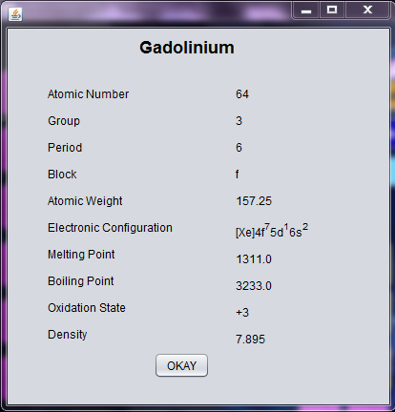

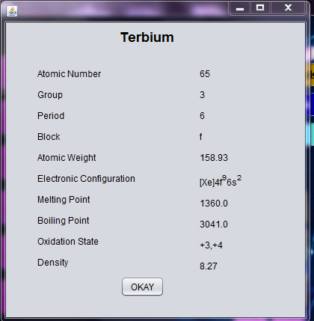 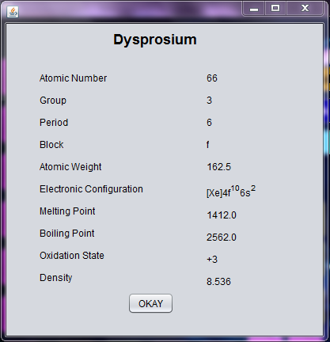

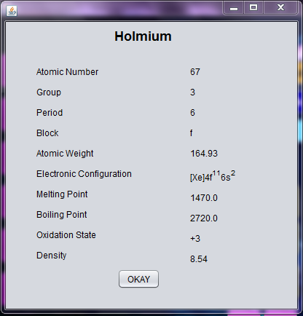 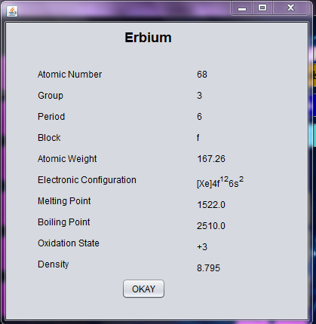

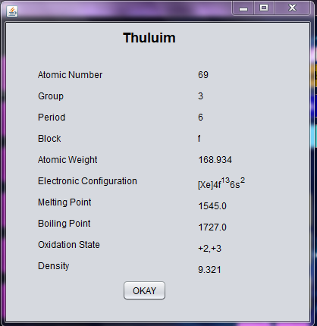 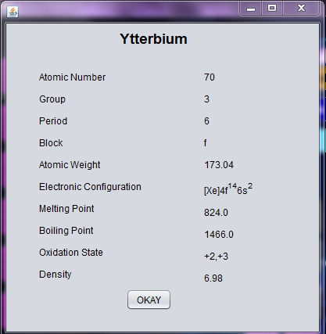

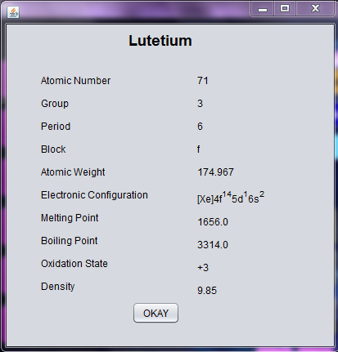 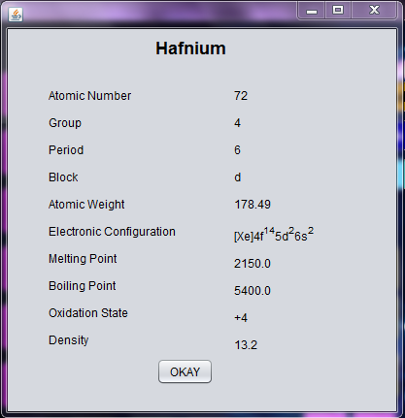

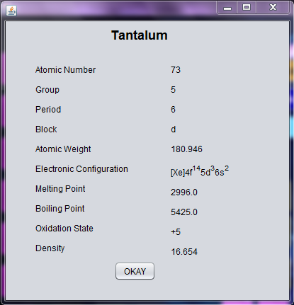 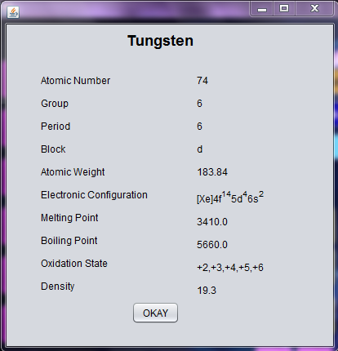

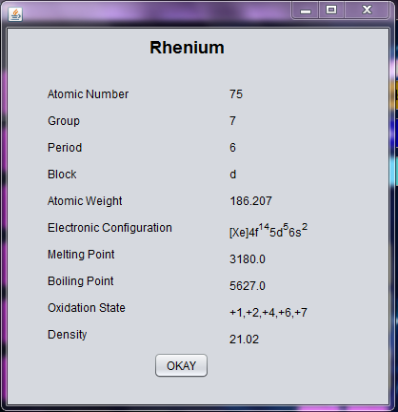 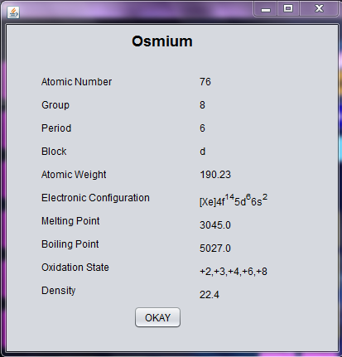

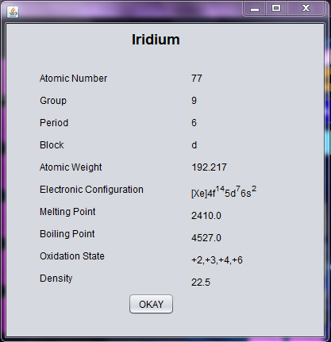 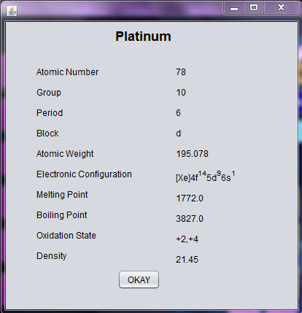

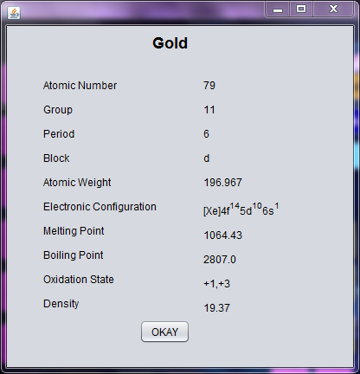 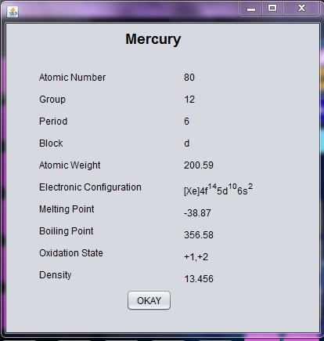

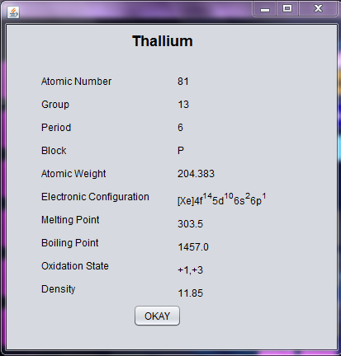 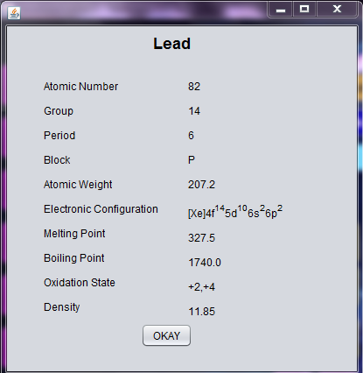

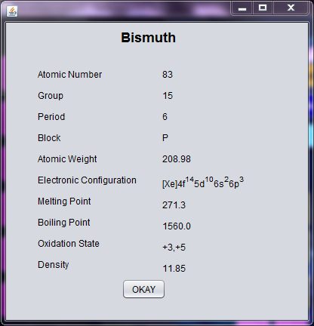 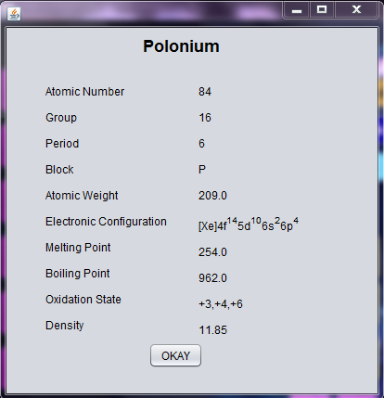

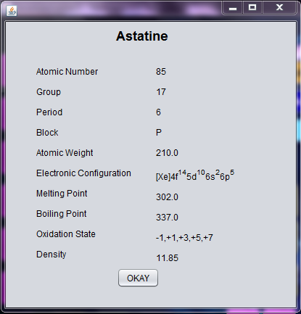 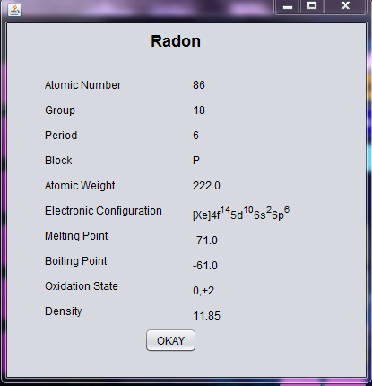

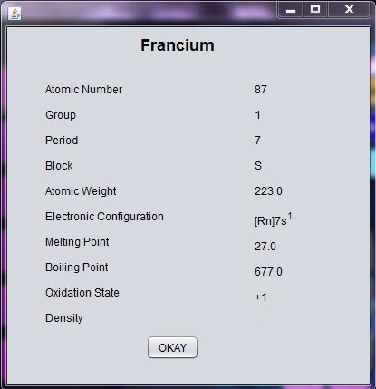 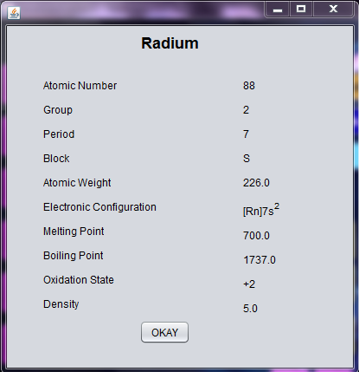

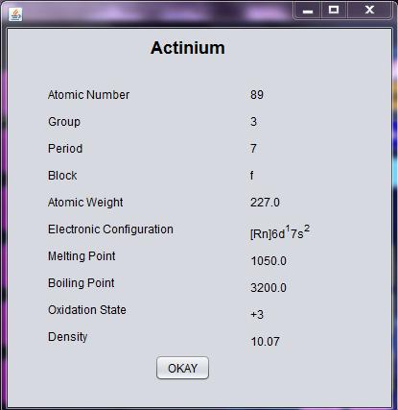 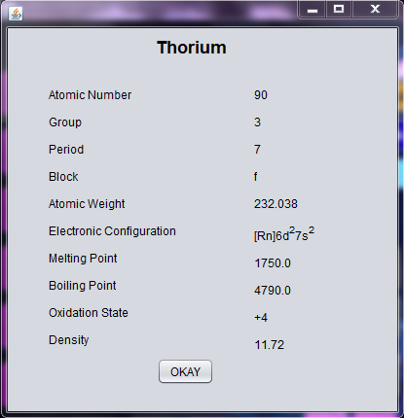

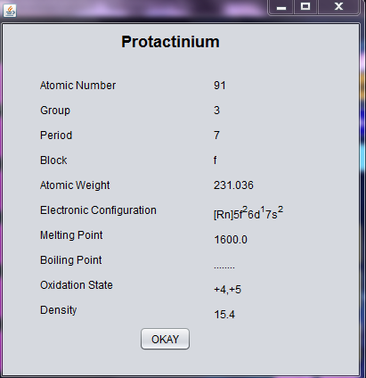 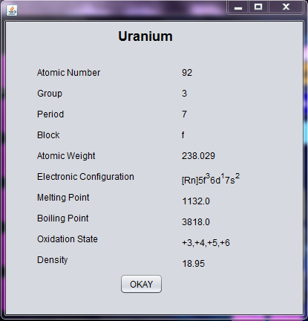

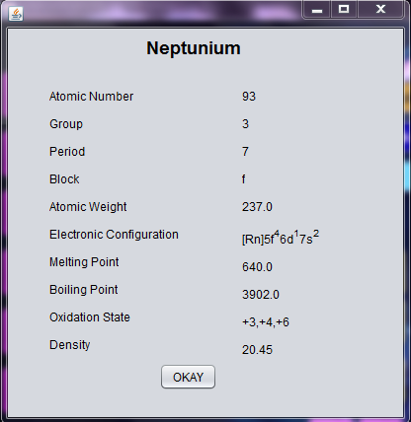 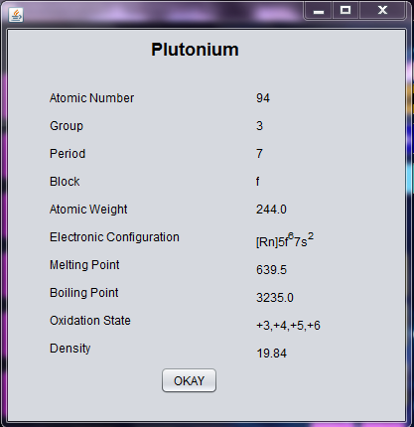

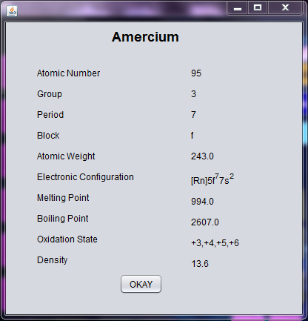 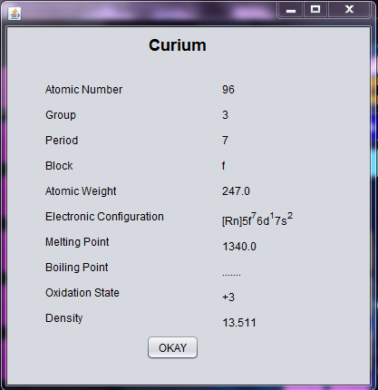

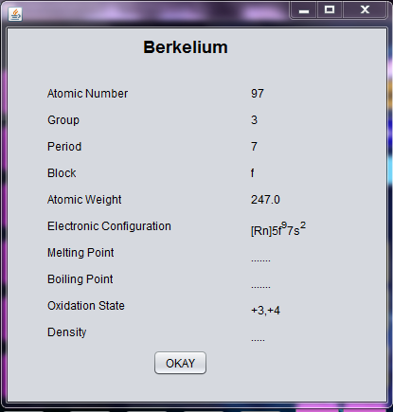 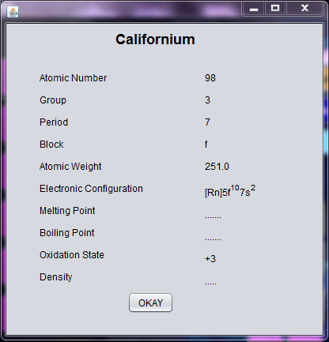

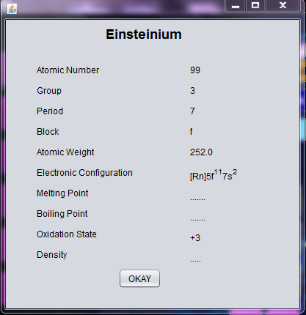 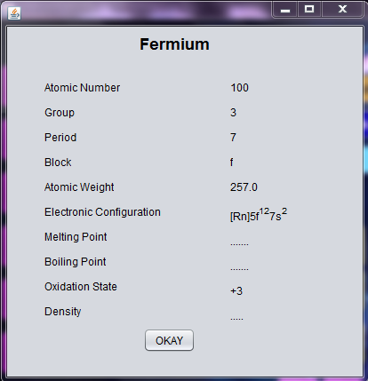

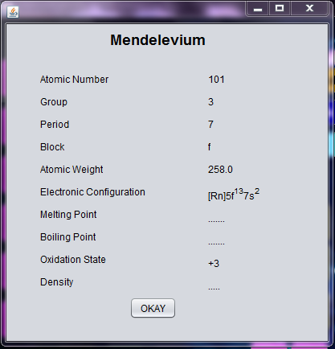 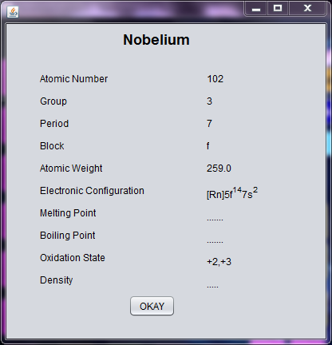

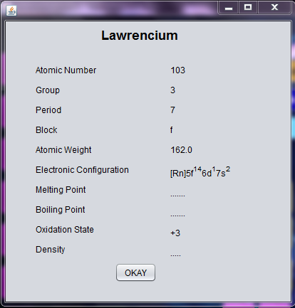 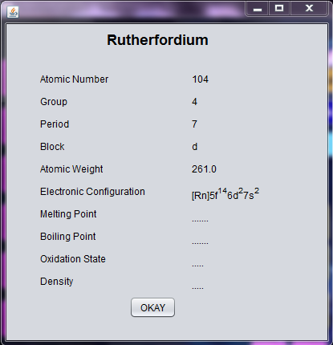

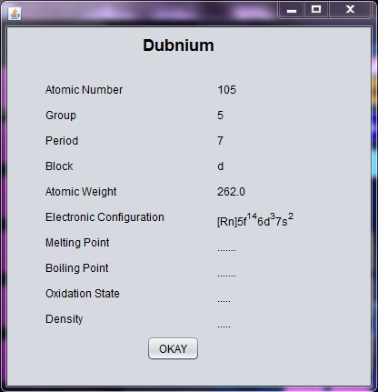 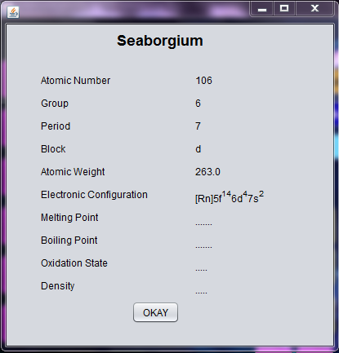

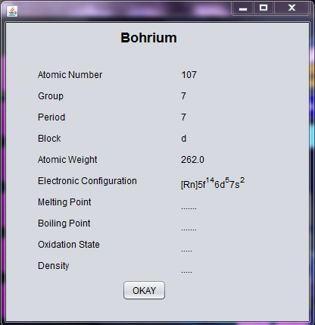 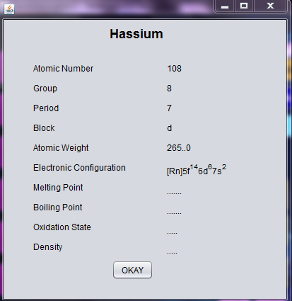

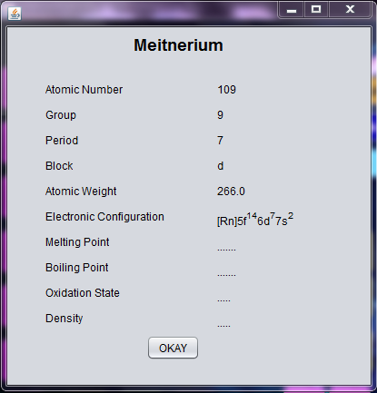 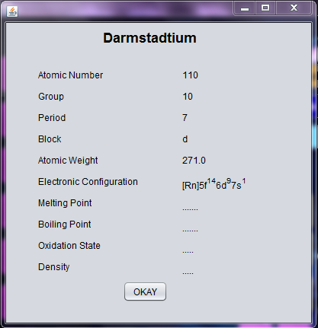

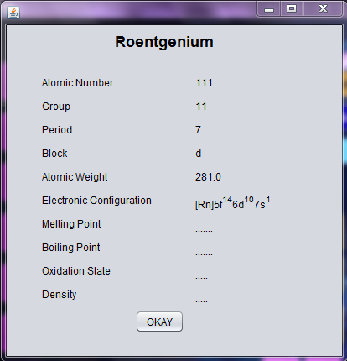 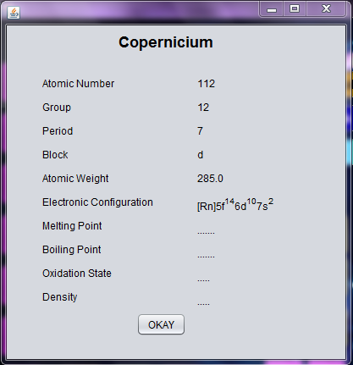

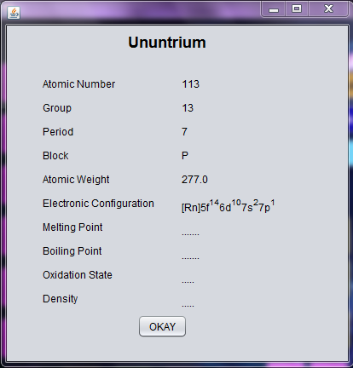 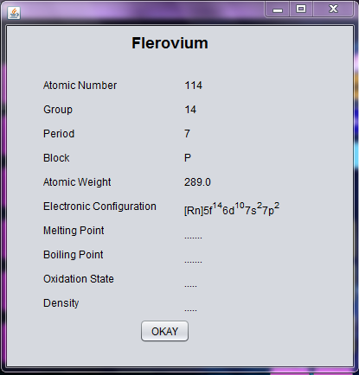

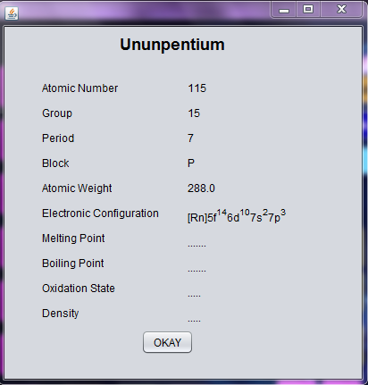 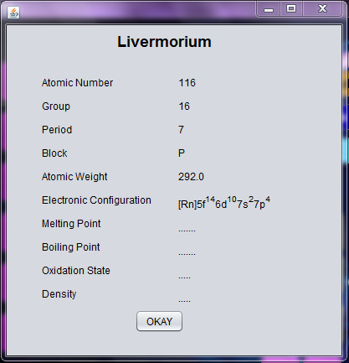

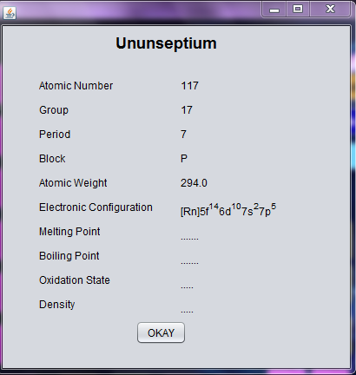 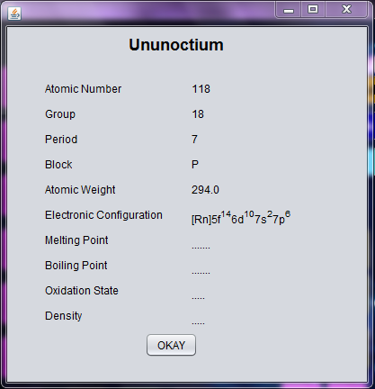

**NOTE:** The names of the above frame forms are same as the symbolic representation of the respective elements. For example, name of the form for Hydrogen is ‘H’, for Helium is ‘He’ and so on.

## I/O Forms Design & Event Coding:

The software project for The Periodic Table contains various forms along with programming codes. Forms (JFrames) and their event coding are given below.

Frame: Front_Page.java

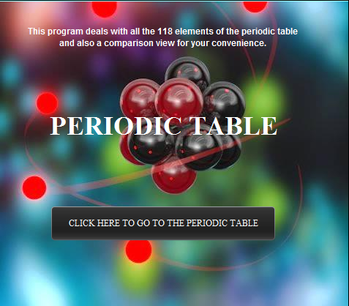

private void jButton1ActionPerformed(java.awt.event.ActionEvent evt) {

this.setVisible(false);

NewJFrame a=new NewJFrame();

a.setVisible(true);// TODO add your handling code here:

Frame: NewJFrame .java

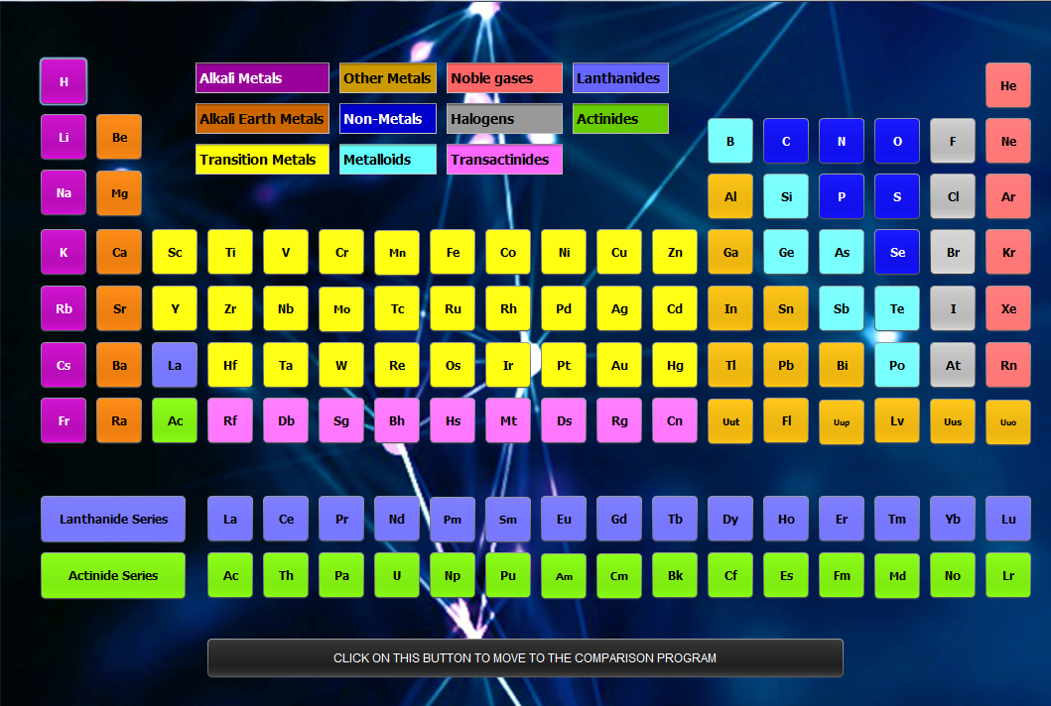

private void jButton5ActionPerformed(java.awt.event.ActionEvent evt) {

Mg a=new Mg();

a.setVisible(true); // TODO add your handling code here:

}

private void jButton12ActionPerformed(java.awt.event.ActionEvent evt) {

Mn a=new Mn();

a.setVisible(true); // TODO add your handling code here:

}

private void jButton63ActionPerformed(java.awt.event.ActionEvent evt) {

Uup a=new Uup();

a.setVisible(true); // TODO add your handling code here:

}

private void jButton1ActionPerformed(java.awt.event.ActionEvent evt) {

H a=new H();

a.setVisible(true);// TODO add your handling code here:

}

private void jButton90ActionPerformed(java.awt.event.ActionEvent evt) {

He a=new He();

a.setVisible(true); // TODO add your handling code here:

}

private void jButton2ActionPerformed(java.awt.event.ActionEvent evt) {

Li a=new Li();

a.setVisible(true); // TODO add your handling code here:

}

private void jButton3ActionPerformed(java.awt.event.ActionEvent evt) {

Be a=new Be();

a.setVisible(true); // TODO add your handling code here:

}

private void jButton79ActionPerformed(java.awt.event.ActionEvent evt) {

B a=new B();

a.setVisible(true); // TODO add your handling code here:

}

private void jButton80ActionPerformed(java.awt.event.ActionEvent evt) {

C a=new C();

a.setVisible(true); // TODO add your handling code here:

}

private void jButton81ActionPerformed(java.awt.event.ActionEvent evt) {

N a=new N();

a.setVisible(true); // TODO add your handling code here:

}

private void jButton83ActionPerformed(java.awt.event.ActionEvent evt) {

O a=new O();

a.setVisible(true); // TODO add your handling code here:

}

private void jButton82ActionPerformed(java.awt.event.ActionEvent evt) {

F a=new F();

a.setVisible(true); // TODO add your handling code here:

}

private void jButton78ActionPerformed(java.awt.event.ActionEvent evt) {

Ne a=new Ne();

a.setVisible(true); // TODO add your handling code here:

}

private void jButton4ActionPerformed(java.awt.event.ActionEvent evt) {

Na a=new Na();

a.setVisible(true); // TODO add your handling code here:

}

private void jButton86ActionPerformed(java.awt.event.ActionEvent evt) {

Al a=new Al();

a.setVisible(true); // TODO add your handling code here:

}

private void jButton84ActionPerformed(java.awt.event.ActionEvent evt) {

Si a=new Si();

a.setVisible(true); // TODO add your handling code here:

}

private void jButton89ActionPerformed(java.awt.event.ActionEvent evt) {

P a=new P();

a.setVisible(true); // TODO add your handling code here:

}

private void jButton87ActionPerformed(java.awt.event.ActionEvent evt) {

S a=new S();

a.setVisible(true); // TODO add your handling code here:

}

private void jButton88ActionPerformed(java.awt.event.ActionEvent evt) {

Cl a=new Cl();

a.setVisible(true); // TODO add your handling code here:

}

private void jButton85ActionPerformed(java.awt.event.ActionEvent evt) {

Ar a=new Ar();

a.setVisible(true); // TODO add your handling code here:

}

private void jButton7ActionPerformed(java.awt.event.ActionEvent evt) {

K a=new K();

a.setVisible(true); // TODO add your handling code here:

}

private void jButton6ActionPerformed(java.awt.event.ActionEvent evt) {

Ca a=new Ca();

a.setVisible(true); // TODO add your handling code here:

}

private void jButton8ActionPerformed(java.awt.event.ActionEvent evt) {

Sc a=new Sc();

a.setVisible(true); // TODO add your handling code here:

}

private void jButton9ActionPerformed(java.awt.event.ActionEvent evt) {

Ti a=new Ti();

a.setVisible(true); // TODO add your handling code here:

}

private void jButton10ActionPerformed(java.awt.event.ActionEvent evt) {

V a=new V();

a.setVisible(true); // TODO add your handling code here:

}

private void jButton11ActionPerformed(java.awt.event.ActionEvent evt) {

Cr a=new Cr();

a.setVisible(true); // TODO add your handling code here:

}

private void jButton13ActionPerformed(java.awt.event.ActionEvent evt) {

Fe a=new Fe();

a.setVisible(true); // TODO add your handling code here:

}

private void jButton14ActionPerformed(java.awt.event.ActionEvent evt) {

Co a=new Co();

a.setVisible(true); // TODO add your handling code here:

}

private void jButton15ActionPerformed(java.awt.event.ActionEvent evt) {

Ni a=new Ni();

a.setVisible(true); // TODO add your handling code here:

}

private void jButton16ActionPerformed(java.awt.event.ActionEvent evt) {

Cu a=new Cu();

a.setVisible(true); // TODO add your handling code here:

}

private void jButton17ActionPerformed(java.awt.event.ActionEvent evt) {

Zn a=new Zn();

a.setVisible(true); // TODO add your handling code here:

}

private void jButton18ActionPerformed(java.awt.event.ActionEvent evt) {

Ga a=new Ga();

a.setVisible(true); // TODO add your handling code here:

}

private void jButton19ActionPerformed(java.awt.event.ActionEvent evt) {

Ge a=new Ge();

a.setVisible(true); // TODO add your handling code here:

}

private void jButton20ActionPerformed(java.awt.event.ActionEvent evt) {

As a=new As();

a.setVisible(true); // TODO add your handling code here:

}

private void jButton21ActionPerformed(java.awt.event.ActionEvent evt) {

Se a=new Se();

a.setVisible(true); // TODO add your handling code here:

}

private void jButton22ActionPerformed(java.awt.event.ActionEvent evt) {

Br a=new Br();

a.setVisible(true); // TODO add your handling code here:

}

private void jButton23ActionPerformed(java.awt.event.ActionEvent evt) {

Kr a=new Kr();

a.setVisible(true); // TODO add your handling code here:

}

private void jButton26ActionPerformed(java.awt.event.ActionEvent evt) {

Rb a=new Rb();

a.setVisible(true); // TODO add your handling code here:

}

private void jButton32ActionPerformed(java.awt.event.ActionEvent evt) {

Sr a=new Sr();

a.setVisible(true); // TODO add your handling code here:

}

private void jButton28ActionPerformed(java.awt.event.ActionEvent evt) {

Y a=new Y();

a.setVisible(true); // TODO add your handling code here:

}

private void jButton24ActionPerformed(java.awt.event.ActionEvent evt) {

Zr a=new Zr();

a.setVisible(true); // TODO add your handling code here:

}

private void jButton38ActionPerformed(java.awt.event.ActionEvent evt) {

Nb a=new Nb();

a.setVisible(true); // TODO add your handling code here:

}

private void jButton37ActionPerformed(java.awt.event.ActionEvent evt) {

Mo a=new Mo();

a.setVisible(true); // TODO add your handling code here:

}

private void jButton25ActionPerformed(java.awt.event.ActionEvent evt) {

Tc a=new Tc();

a.setVisible(true); // TODO add your handling code here:

}

private void jButton27ActionPerformed(java.awt.event.ActionEvent evt) {

Ru a=new Ru();

a.setVisible(true); // TODO add your handling code here:

}

private void jButton30ActionPerformed(java.awt.event.ActionEvent evt) {

Rh a=new Rh();

a.setVisible(true); // TODO add your handling code here:

}

private void jButton31ActionPerformed(java.awt.event.ActionEvent evt) {

Pd a=new Pd();

a.setVisible(true); // TODO add your handling code here:

}

private void jButton33ActionPerformed(java.awt.event.ActionEvent evt) {

Ag a=new Ag();

a.setVisible(true); // TODO add your handling code here:

}

private void jButton34ActionPerformed(java.awt.event.ActionEvent evt) {

Cd a=new Cd();

a.setVisible(true); // TODO add your handling code here:

}

private void jButton35ActionPerformed(java.awt.event.ActionEvent evt) {

In a=new In();

a.setVisible(true); // TODO add your handling code here:

}

private void jButton36ActionPerformed(java.awt.event.ActionEvent evt) {

Sn a=new Sn();

a.setVisible(true); // TODO add your handling code here:

}

private void jButton39ActionPerformed(java.awt.event.ActionEvent evt) {

Sb a=new Sb();

a.setVisible(true); // TODO add your handling code here:

}

private void jButton41ActionPerformed(java.awt.event.ActionEvent evt) {

Te a=new Te();

a.setVisible(true); // TODO add your handling code here:

}

private void jButton40ActionPerformed(java.awt.event.ActionEvent evt) {

I a=new I();

a.setVisible(true); // TODO add your handling code here:

}

private void jButton29ActionPerformed(java.awt.event.ActionEvent evt) {

Xe a=new Xe();

a.setVisible(true); // TODO add your handling code here:

}

private void jButton56ActionPerformed(java.awt.event.ActionEvent evt) {

Cs a=new Cs();

a.setVisible(true); // TODO add your handling code here:

}

private void jButton51ActionPerformed(java.awt.event.ActionEvent evt) {

Ba a=new Ba();

a.setVisible(true); // TODO add your handling code here:

}

private void jButton121ActionPerformed(java.awt.event.ActionEvent evt) {

La a=new La();

a.setVisible(true); // TODO add your handling code here:

}

private void jButton46ActionPerformed(java.awt.event.ActionEvent evt) {

Ce a=new Ce();

a.setVisible(true); // TODO add your handling code here:

}

private void jButton64ActionPerformed(java.awt.event.ActionEvent evt) {

Pr a=new Pr();

a.setVisible(true); // TODO add your handling code here:

}

private void jButton92ActionPerformed(java.awt.event.ActionEvent evt) {

Nd a=new Nd();

a.setVisible(true); // TODO add your handling code here:

}

private void jButton91ActionPerformed(java.awt.event.ActionEvent evt) {

Pm a=new Pm();

a.setVisible(true); // TODO add your handling code here:

}

private void jButton94ActionPerformed(java.awt.event.ActionEvent evt) {

Sm a=new Sm();

a.setVisible(true); // TODO add your handling code here:

}

private void jButton93ActionPerformed(java.awt.event.ActionEvent evt) {

Eu a=new Eu();

a.setVisible(true); // TODO add your handling code here:

}

private void jButton95ActionPerformed(java.awt.event.ActionEvent evt) {

Gd a=new Gd();

a.setVisible(true); // TODO add your handling code here:

}

private void jButton96ActionPerformed(java.awt.event.ActionEvent evt) {

Tb a=new Tb();

a.setVisible(true); // TODO add your handling code here:

}

private void jButton101ActionPerformed(java.awt.event.ActionEvent evt) {

Dy a=new Dy();

a.setVisible(true); // TODO add your handling code here:

}

private void jButton102ActionPerformed(java.awt.event.ActionEvent evt) {

Ho a=new Ho();

a.setVisible(true); // TODO add your handling code here:

}

private void jButton99ActionPerformed(java.awt.event.ActionEvent evt) {

Er a=new Er();

a.setVisible(true); // TODO add your handling code here:

}

private void jButton100ActionPerformed(java.awt.event.ActionEvent evt) {

Tm a=new Tm();

a.setVisible(true); // TODO add your handling code here:

}

private void jButton98ActionPerformed(java.awt.event.ActionEvent evt) {

Yb a=new Yb();

a.setVisible(true); // TODO add your handling code here:

}

private void jButton97ActionPerformed(java.awt.event.ActionEvent evt) {

Lu a=new Lu();

a.setVisible(true); // TODO add your handling code here:

}

private void jButton48ActionPerformed(java.awt.event.ActionEvent evt) {

Hf a=new Hf();

a.setVisible(true); // TODO add your handling code here:

}

private void jButton58ActionPerformed(java.awt.event.ActionEvent evt) {

Ta a=new Ta();

a.setVisible(true); // TODO add your handling code here:

}

private void jButton45ActionPerformed(java.awt.event.ActionEvent evt) {

W a=new W();

a.setVisible(true); // TODO add your handling code here:

}

private void jButton55ActionPerformed(java.awt.event.ActionEvent evt) {

Re a=new Re();

a.setVisible(true); // TODO add your handling code here:

}

private void jButton54ActionPerformed(java.awt.event.ActionEvent evt) {

Os a=new Os();

a.setVisible(true); // TODO add your handling code here:

}

private void jButton42ActionPerformed(java.awt.event.ActionEvent evt) {

Ir a=new Ir();

a.setVisible(true); // TODO add your handling code here:

}

private void jButton47ActionPerformed(java.awt.event.ActionEvent evt) {

Pt a=new Pt();

a.setVisible(true); // TODO add your handling code here:

}

private void jButton57ActionPerformed(java.awt.event.ActionEvent evt) {

Au a=new Au();

a.setVisible(true); // TODO add your handling code here:

}

private void jButton53ActionPerformed(java.awt.event.ActionEvent evt) {

Hg a=new Hg();

a.setVisible(true); // TODO add your handling code here:

}

private void jButton43ActionPerformed(java.awt.event.ActionEvent evt) {

Tl a=new Tl();

a.setVisible(true); // TODO add your handling code here:

}

private void jButton44ActionPerformed(java.awt.event.ActionEvent evt) {

Pb a=new Pb();

a.setVisible(true); // TODO add your handling code here:

}

private void jButton52ActionPerformed(java.awt.event.ActionEvent evt) {

Bi a=new Bi();

a.setVisible(true); // TODO add your handling code here:

}

private void jButton49ActionPerformed(java.awt.event.ActionEvent evt) {

Po a=new Po();

a.setVisible(true); // TODO add your handling code here:

}

private void jButton59ActionPerformed(java.awt.event.ActionEvent evt) {

At a=new At();

a.setVisible(true); // TODO add your handling code here:

}

private void jButton50ActionPerformed(java.awt.event.ActionEvent evt) {

Rn a=new Rn();

a.setVisible(true); // TODO add your handling code here:

}

private void jButton70ActionPerformed(java.awt.event.ActionEvent evt) {

Fr a=new Fr();

a.setVisible(true); // TODO add your handling code here:

}

private void jButton73ActionPerformed(java.awt.event.ActionEvent evt) {

Ra a=new Ra();

a.setVisible(true); // TODO add your handling code here:

}

private void jButton122ActionPerformed(java.awt.event.ActionEvent evt) {

Ac a=new Ac();

a.setVisible(true); // TODO add your handling code here:

}

private void jButton116ActionPerformed(java.awt.event.ActionEvent evt) {

Th a=new Th();

a.setVisible(true); // TODO add your handling code here:

}

private void jButton115ActionPerformed(java.awt.event.ActionEvent evt) {

Pa a=new Pa();

a.setVisible(true); // TODO add your handling code here:

}

private void jButton108ActionPerformed(java.awt.event.ActionEvent evt) {

U a=new U();

a.setVisible(true); // TODO add your handling code here:

}

private void jButton109ActionPerformed(java.awt.event.ActionEvent evt) {

Np a=new Np();

a.setVisible(true); // TODO add your handling code here:

}

private void jButton106ActionPerformed(java.awt.event.ActionEvent evt) {

Pu a=new Pu();

a.setVisible(true); // TODO add your handling code here:

}

private void jButton107ActionPerformed(java.awt.event.ActionEvent evt) {

Am a=new Am();

a.setVisible(true); // TODO add your handling code here:

}

private void jButton105ActionPerformed(java.awt.event.ActionEvent evt) {

Cm a=new Cm();

a.setVisible(true); // TODO add your handling code here:

}

private void jButton104ActionPerformed(java.awt.event.ActionEvent evt) {

Bk a=new Bk();

a.setVisible(true); // TODO add your handling code here:

}

private void jButton112ActionPerformed(java.awt.event.ActionEvent evt) {

Cf a=new Cf();

a.setVisible(true); // TODO add your handling code here:

}

private void jButton110ActionPerformed(java.awt.event.ActionEvent evt) {

Es a=new Es();

a.setVisible(true); // TODO add your handling code here:

}

private void jButton114ActionPerformed(java.awt.event.ActionEvent evt) {

Fm a=new Fm();

a.setVisible(true); // TODO add your handling code here:

}

private void jButton111ActionPerformed(java.awt.event.ActionEvent evt) {

Md a=new Md();

a.setVisible(true); // TODO add your handling code here:

}

private void jButton113ActionPerformed(java.awt.event.ActionEvent evt) {

No a=new No();

a.setVisible(true); // TODO add your handling code here:

}

private void jButton103ActionPerformed(java.awt.event.ActionEvent evt) {

Lr a=new Lr();

a.setVisible(true); // TODO add your handling code here:

}

private void jButton71ActionPerformed(java.awt.event.ActionEvent evt) {

Rf a=new Rf();

a.setVisible(true); // TODO add your handling code here:

}

private void jButton69ActionPerformed(java.awt.event.ActionEvent evt) {

Db a=new Db();

a.setVisible(true); // TODO add your handling code here:

}

private void jButton61ActionPerformed(java.awt.event.ActionEvent evt) {

Sg a=new Sg();

a.setVisible(true); // TODO add your handling code here:

}

private void jButton67ActionPerformed(java.awt.event.ActionEvent evt) {

Bh a=new Bh();

a.setVisible(true); // TODO add your handling code here:

}

private void jButton76ActionPerformed(java.awt.event.ActionEvent evt) {

Hs a=new Hs();

a.setVisible(true); // TODO add your handling code here:

}

private void jButton77ActionPerformed(java.awt.event.ActionEvent evt) {

Mt a=new Mt();

a.setVisible(true); // TODO add your handling code here:

}

private void jButton60ActionPerformed(java.awt.event.ActionEvent evt) {

Ds a=new Ds();

a.setVisible(true); // TODO add your handling code here:

}

private void jButton66ActionPerformed(java.awt.event.ActionEvent evt) {

Rg a=new Rg();

a.setVisible(true); // TODO add your handling code here:

}

private void jButton65ActionPerformed(java.awt.event.ActionEvent evt) {

Cn a=new Cn();

a.setVisible(true); // TODO add your handling code here:

}

private void jButton68ActionPerformed(java.awt.event.ActionEvent evt) {

Uut a=new Uut();

a.setVisible(true); // TODO add your handling code here:

}

private void jButton75ActionPerformed(java.awt.event.ActionEvent evt) {

Fl a=new Fl();

a.setVisible(true); // TODO add your handling code here:

}

private void jButton62ActionPerformed(java.awt.event.ActionEvent evt) {

Lv a=new Lv();

a.setVisible(true); // TODO add your handling code here:

}

private void jButton74ActionPerformed(java.awt.event.ActionEvent evt) {

Uus a=new Uus();

a.setVisible(true); // TODO add your handling code here:

}

private void jButton72ActionPerformed(java.awt.event.ActionEvent evt) {

Uuo a=new Uuo();

a.setVisible(true); // TODO add your handling code here:

}

private void jButton123ActionPerformed(java.awt.event.ActionEvent evt) {

this.setVisible(false);

Comparison a=new Comparison();

a.setVisible(true);

// TODO add your handling code here:

}

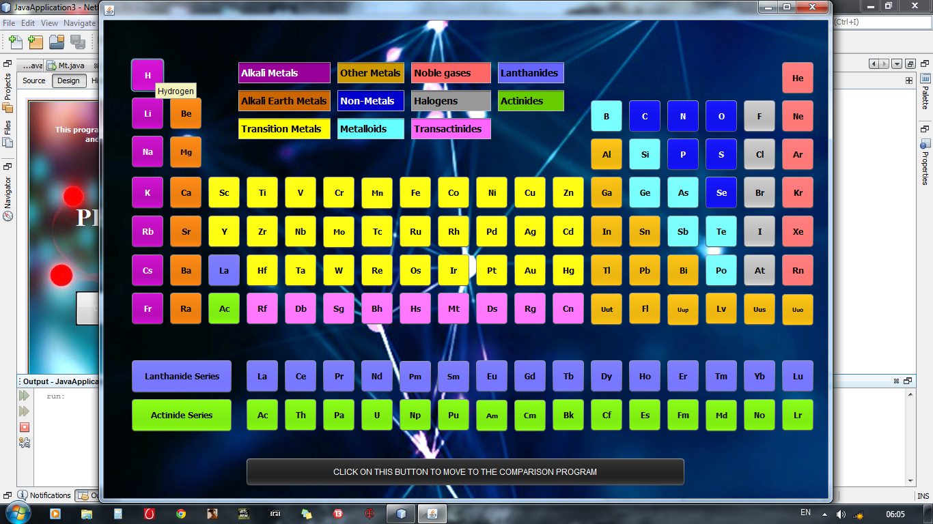

The program involves Tool Tip Text that shows the name of the elements when we move cursor towards a button.

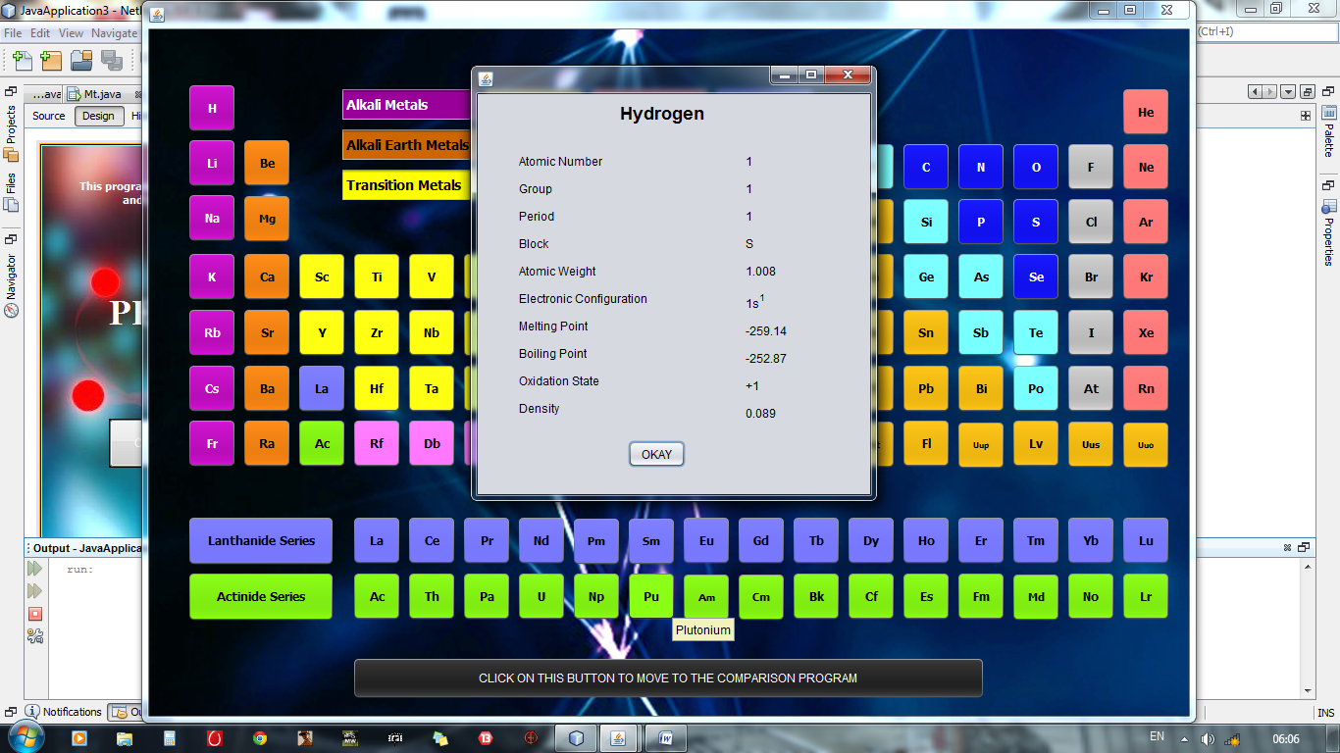

This is how we can get general information about any element.

Frame: Comparison .java

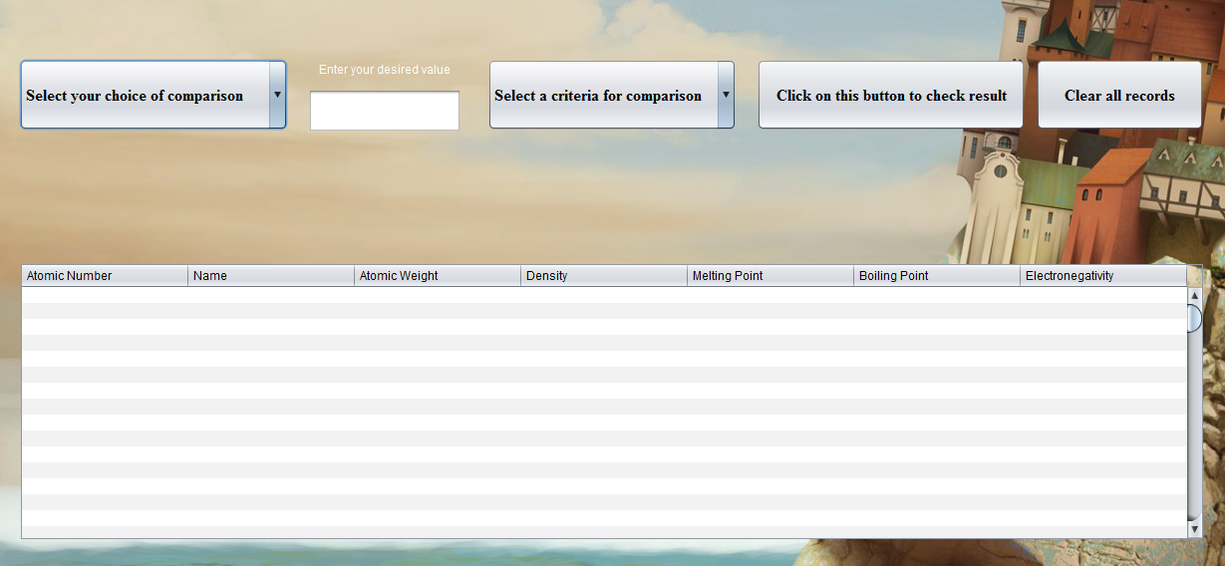

import java.sql.*;

import javax.swing.JOptionPane;

import javax.swing.table.DefaultTableModel;

public class Comparison extends javax.swing.JFrame {

jTable1.setModel(new javax.swing.table.DefaultTableModel(

new Object [][] {

},

new String [] {

"Atomic Number", "Name", "Atomic Weight", "Density", "Melting Point", "Boiling Point", "Electronegativity"

}

)

private void jTextField1ActionPerformed(java.awt.event.ActionEvent evt) {

// TODO add your handling code here:

}

private void jComboBox1ActionPerformed(java.awt.event.ActionEvent evt) {

// TODO add your handling code here:

}

private void jComboBox2ActionPerformed(java.awt.event.ActionEvent evt) {

// TODO add your handling code here:

}

private void jButton1ActionPerformed(java.awt.event.ActionEvent evt) {

DefaultTableModel tt=(DefaultTableModel)jTable1.getModel();

//tt.removeRow(tt.getRowCount());

int num;

String an;

double am,de,mp,bp,en;

num=Integer.parseInt(jTextField1.getText());

try{

Class.forName("java.sql.DriverManager");

Connection cc=(Connection)DriverManager.getConnection("jdbc:mysql://localhost:3306/periodic","root","one");

Statement st=(Statement)cc.createStatement();

//atomic no

if(jComboBox1.getSelectedIndex()==1){

//=

if(jComboBox2.getSelectedIndex()==1){

ResultSet rr=st.executeQuery("select Element_name,Atomic_mass,Density,Melting_point,Boiling_point,Electronegativity from elements where (Atomic_number='"+num+"');");

while(rr.next()){

an=rr.getString("Element_name");

am=rr.getDouble("Atomic_mass");

de=rr.getDouble("Density");

mp=rr.getDouble("Melting_point");

bp=rr.getDouble("Boiling_point");

en=rr.getDouble("Electronegativity");

Object rec[]={num,an,am,de,mp,bp,en};

tt.addRow(rec);}

}

//<

if(jComboBox2.getSelectedIndex()==2){

ResultSet rr=st.executeQuery("select * from elements where Atomic_number<'"+num+"'; ");

while(rr.next()){

num=rr.getInt(1);

an=rr.getString(2);

am=rr.getDouble(3);

de=rr.getDouble(4);

mp=rr.getDouble(5);

bp=rr.getDouble(6);

en=rr.getDouble(7);

Object rec[]={num,an,am,de,mp,bp,en};

tt.addRow(rec);

}}

//>

if(jComboBox2.getSelectedIndex()==3){

ResultSet rr=st.executeQuery("select * from elements where Atomic_number>'"+num+"'; ");

while(rr.next()){

num=rr.getInt(1);

an=rr.getString(2);

am=rr.getDouble(3);

de=rr.getDouble(4);

mp=rr.getDouble(5);

bp=rr.getDouble(6);

en=rr.getDouble(7);

Object rec[]={num,an,am,de,mp,bp,en};

tt.addRow(rec);

}

}

//<=

if(jComboBox2.getSelectedIndex()==4){

ResultSet rr=st.executeQuery("select * from elements where Atomic_number<='"+num+"'; ");

while(rr.next()){

num=rr.getInt(1);

an=rr.getString(2);

am=rr.getDouble(3);

de=rr.getDouble(4);

mp=rr.getDouble(5);

bp=rr.getDouble(6);

en=rr.getDouble(7);

Object rec[]={num,an,am,de,mp,bp,en};

tt.addRow(rec);

}}

//>=

if(jComboBox2.getSelectedIndex()==5){

ResultSet rr=st.executeQuery("select * from elements where Atomic_number>='"+num+"'; ");

while(rr.next()){

num=rr.getInt(1);

an=rr.getString(2);

am=rr.getDouble(3);

de=rr.getDouble(4);

mp=rr.getDouble(5);

bp=rr.getDouble(6);

en=rr.getDouble(7);

Object rec[]={num,an,am,de,mp,bp,en};

tt.addRow(rec);

}

}

}//end of atomic no

//atomic mass

am=Double.parseDouble(jTextField1.getText());

if(jComboBox1.getSelectedIndex()==2){

if(jComboBox2.getSelectedIndex()==1){

ResultSet rr=st.executeQuery("select Element_name,Atomic_mass,Density,Melting_point,Boiling_point,Electronegativity from elements where (Atomic_mass='"+am+"');");

while(rr.next()){

an=rr.getString("Element_name");

am=rr.getDouble("Atomic_mass");

de=rr.getDouble("Density");

mp=rr.getDouble("Melting_point");

bp=rr.getDouble("Boiling_point");

en=rr.getDouble("Electronegativity");

Object rec[]={num,an,am,de,mp,bp,en};

tt.addRow(rec);}

}

if(jComboBox2.getSelectedIndex()==2){

ResultSet rr=st.executeQuery("select * from elements where Atomic_mass<'"+am+"'; ");

while(rr.next()){

num=rr.getInt(1);

an=rr.getString(2);

am=rr.getDouble(3);

de=rr.getDouble(4);

mp=rr.getDouble(5);

bp=rr.getDouble(6);

en=rr.getDouble(7);

Object rec[]={num,an,am,de,mp,bp,en};

tt.addRow(rec);

}}

if(jComboBox2.getSelectedIndex()==3){

ResultSet rr=st.executeQuery("select * from elements where Atomic_mass>'"+am+"'; ");

while(rr.next()){

num=rr.getInt(1);

an=rr.getString(2);

am=rr.getDouble(3);

de=rr.getDouble(4);

mp=rr.getDouble(5);

bp=rr.getDouble(6);

en=rr.getDouble(7);

Object rec[]={num,an,am,de,mp,bp,en};

tt.addRow(rec);

}

}

if(jComboBox2.getSelectedIndex()==4){

ResultSet rr=st.executeQuery("select * from elements where Atomic_mass<='"+am+"'; ");

while(rr.next()){

num=rr.getInt(1);

an=rr.getString(2);

am=rr.getDouble(3);

de=rr.getDouble(4);

mp=rr.getDouble(5);

bp=rr.getDouble(6);

en=rr.getDouble(7);

Object rec[]={num,an,am,de,mp,bp,en};

tt.addRow(rec);

}}

if(jComboBox2.getSelectedIndex()==5){

ResultSet rr=st.executeQuery("select * from elements where Atomic_mass>='"+am+"'; ");

while(rr.next()){

num=rr.getInt(1);

an=rr.getString(2);

am=rr.getDouble(3);

de=rr.getDouble(4);

mp=rr.getDouble(5);

bp=rr.getDouble(6);

en=rr.getDouble(7);

Object rec[]={num,an,am,de,mp,bp,en};

tt.addRow(rec);

}

}

}

de=Double.parseDouble(jTextField1.getText());

if(jComboBox1.getSelectedIndex()==3)

{if(jComboBox2.getSelectedIndex()==1){

ResultSet rr=st.executeQuery("select Element_name,Atomic_mass,Density,Melting_point,Boiling_point,Electronegativity from elements where (Density='"+de+"');");

while(rr.next()){

an=rr.getString("Element_name");

am=rr.getDouble("Atomic_mass");

de=rr.getDouble("Density");

mp=rr.getDouble("Melting_point");

bp=rr.getDouble("Boiling_point");

en=rr.getDouble("Electronegativity");

Object rec[]={num,an,am,de,mp,bp,en};

tt.addRow(rec);}

}

if(jComboBox2.getSelectedIndex()==2){

ResultSet rr=st.executeQuery("select * from elements where Density<'"+de+"'; ");

while(rr.next()){

num=rr.getInt(1);

an=rr.getString(2);

am=rr.getDouble(3);

de=rr.getDouble(4);

mp=rr.getDouble(5);

bp=rr.getDouble(6);

en=rr.getDouble(7);

Object rec[]={num,an,am,de,mp,bp,en};

tt.addRow(rec);

}}

if(jComboBox2.getSelectedIndex()==3){

ResultSet rr=st.executeQuery("select * from elements where Density>'"+de+"'; ");

while(rr.next()){

num=rr.getInt(1);

an=rr.getString(2);

am=rr.getDouble(3);

de=rr.getDouble(4);

mp=rr.getDouble(5);

bp=rr.getDouble(6);

en=rr.getDouble(7);

Object rec[]={num,an,am,de,mp,bp,en};

tt.addRow(rec);

}

}

if(jComboBox2.getSelectedIndex()==4){

ResultSet rr=st.executeQuery("select * from elements where Density<='"+de+"'; ");

while(rr.next()){

num=rr.getInt(1);

an=rr.getString(2);

am=rr.getDouble(3);

de=rr.getDouble(4);

mp=rr.getDouble(5);

bp=rr.getDouble(6);

en=rr.getDouble(7);

Object rec[]={num,an,am,de,mp,bp,en};

tt.addRow(rec);

}}

if(jComboBox2.getSelectedIndex()==5){

ResultSet rr=st.executeQuery("select * from elements where Density>='"+de+"'; ");

while(rr.next()){

num=rr.getInt(1);

an=rr.getString(2);

am=rr.getDouble(3);

de=rr.getDouble(4);

mp=rr.getDouble(5);

bp=rr.getDouble(6);

en=rr.getDouble(7);

Object rec[]={num,an,am,de,mp,bp,en};

tt.addRow(rec);

}

}}

mp=Double.parseDouble(jTextField1.getText());

if(jComboBox1.getSelectedIndex()==4)

{if(jComboBox2.getSelectedIndex()==1){

ResultSet rr=st.executeQuery("select Element_name,Atomic_mass,Density,Melting_point,Boiling_point,Electronegativity from elements where (Melting_point='"+mp+"');");

while(rr.next()){

an=rr.getString("Element_name");

am=rr.getDouble("Atomic_mass");

de=rr.getDouble("Density");

mp=rr.getDouble("Melting_point");

bp=rr.getDouble("Boiling_point");

en=rr.getDouble("Electronegativity");

Object rec[]={num,an,am,de,mp,bp,en};

tt.addRow(rec);}

}

if(jComboBox2.getSelectedIndex()==2){

ResultSet rr=st.executeQuery("select * from elements where Melting_point<'"+mp+"'; ");

while(rr.next()){

num=rr.getInt(1);

an=rr.getString(2);

am=rr.getDouble(3);

de=rr.getDouble(4);

mp=rr.getDouble(5);

bp=rr.getDouble(6);

en=rr.getDouble(7);

Object rec[]={num,an,am,de,mp,bp,en};

tt.addRow(rec);

}}

if(jComboBox2.getSelectedIndex()==3){

ResultSet rr=st.executeQuery("select * from elements where Melting_point>'"+mp+"'; ");

while(rr.next()){

num=rr.getInt(1);

an=rr.getString(2);

am=rr.getDouble(3);

de=rr.getDouble(4);

mp=rr.getDouble(5);

bp=rr.getDouble(6);

en=rr.getDouble(7);

Object rec[]={num,an,am,de,mp,bp,en};

tt.addRow(rec);

}

}

if(jComboBox2.getSelectedIndex()==4){

ResultSet rr=st.executeQuery("select * from elements where Melting_point<='"+mp+"'; ");

while(rr.next()){

num=rr.getInt(1);

an=rr.getString(2);

am=rr.getDouble(3);

de=rr.getDouble(4);

mp=rr.getDouble(5);

bp=rr.getDouble(6);

en=rr.getDouble(7);

Object rec[]={num,an,am,de,mp,bp,en};

tt.addRow(rec);

}}

if(jComboBox2.getSelectedIndex()==5){

ResultSet rr=st.executeQuery("select * from elements where Melting_point>='"+mp+"'; ");

while(rr.next()){

num=rr.getInt(1);

an=rr.getString(2);

am=rr.getDouble(3);

de=rr.getDouble(4);

mp=rr.getDouble(5);

bp=rr.getDouble(6);

en=rr.getDouble(7);

Object rec[]={num,an,am,de,mp,bp,en};

tt.addRow(rec);

}

}}

bp=Double.parseDouble(jTextField1.getText());

if(jComboBox1.getSelectedIndex()==5)

{if(jComboBox2.getSelectedIndex()==1){

ResultSet rr=st.executeQuery("select Element_name,Atomic_mass,Density,Melting_point,Boiling_point,Electronegativity from elements where (Boiling_point='"+bp+"');");

while(rr.next()){

an=rr.getString("Element_name");

am=rr.getDouble("Atomic_mass");

de=rr.getDouble("Density");

mp=rr.getDouble("Melting_point");

bp=rr.getDouble("Boiling_point");

en=rr.getDouble("Electronegativity");

Object rec[]={num,an,am,de,mp,bp,en};

tt.addRow(rec);}

}

if(jComboBox2.getSelectedIndex()==2){

ResultSet rr=st.executeQuery("select * from elements where Boiling_point<'"+bp+"'; ");

while(rr.next()){

num=rr.getInt(1);

an=rr.getString(2);

am=rr.getDouble(3);

de=rr.getDouble(4);

mp=rr.getDouble(5);

bp=rr.getDouble(6);

en=rr.getDouble(7);

Object rec[]={num,an,am,de,mp,bp,en};

tt.addRow(rec);

}}

if(jComboBox2.getSelectedIndex()==3){

ResultSet rr=st.executeQuery("select * from elements where Boiling_point>'"+bp+"'; ");

while(rr.next()){

num=rr.getInt(1);

an=rr.getString(2);

am=rr.getDouble(3);

de=rr.getDouble(4);

mp=rr.getDouble(5);

bp=rr.getDouble(6);

en=rr.getDouble(7);

Object rec[]={num,an,am,de,mp,bp,en};

tt.addRow(rec);

}

}

if(jComboBox2.getSelectedIndex()==4){

ResultSet rr=st.executeQuery("select * from elements where Boiling_point<='"+bp+"'; ");

while(rr.next()){

num=rr.getInt(1);

an=rr.getString(2);

am=rr.getDouble(3);

de=rr.getDouble(4);

mp=rr.getDouble(5);

bp=rr.getDouble(6);

en=rr.getDouble(7);

Object rec[]={num,an,am,de,mp,bp,en};

tt.addRow(rec);

}}

if(jComboBox2.getSelectedIndex()==5){

ResultSet rr=st.executeQuery("select * from elements where Boiling_point>='"+bp+"'; ");

while(rr.next()){

num=rr.getInt(1);

an=rr.getString(2);

am=rr.getDouble(3);

de=rr.getDouble(4);

mp=rr.getDouble(5);

bp=rr.getDouble(6);

en=rr.getDouble(7);

Object rec[]={num,an,am,de,mp,bp,en};

tt.addRow(rec);

}

}}

en=Double.parseDouble(jTextField1.getText());

if(jComboBox1.getSelectedIndex()==6)

{if(jComboBox2.getSelectedIndex()==1){

ResultSet rr=st.executeQuery("select Element_name,Atomic_mass,Density,Melting_point,Boiling_point,Electronegativity from elements where (Electronegativity='"+en+"');");

while(rr.next()){

an=rr.getString("Element_name");

am=rr.getDouble("Atomic_mass");

de=rr.getDouble("Density");

mp=rr.getDouble("Melting_point");

bp=rr.getDouble("Boiling_point");

en=rr.getDouble("Electronegativity");

Object rec[]={num,an,am,de,mp,bp,en};

tt.addRow(rec);}

}

if(jComboBox2.getSelectedIndex()==2){

ResultSet rr=st.executeQuery("select * from elements where Electronegativity<'"+en+"'; ");

while(rr.next()){

num=rr.getInt(1);

an=rr.getString(2);

am=rr.getDouble(3);

de=rr.getDouble(4);

mp=rr.getDouble(5);

bp=rr.getDouble(6);

en=rr.getDouble(7);

Object rec[]={num,an,am,de,mp,bp,en};

tt.addRow(rec);

}}

if(jComboBox2.getSelectedIndex()==3){

ResultSet rr=st.executeQuery("select * from elements where Electronegativity>'"+en+"'; ");

while(rr.next()){

num=rr.getInt(1);

an=rr.getString(2);

am=rr.getDouble(3);

de=rr.getDouble(4);

mp=rr.getDouble(5);

bp=rr.getDouble(6);

en=rr.getDouble(7);

Object rec[]={num,an,am,de,mp,bp,en};

tt.addRow(rec);

}

}

if(jComboBox2.getSelectedIndex()==4){

ResultSet rr=st.executeQuery("select * from elements where Electronegativity<='"+en+"'; ");

while(rr.next()){

num=rr.getInt(1);

an=rr.getString(2);

am=rr.getDouble(3);

de=rr.getDouble(4);

mp=rr.getDouble(5);

bp=rr.getDouble(6);

en=rr.getDouble(7);

Object rec[]={num,an,am,de,mp,bp,en};

tt.addRow(rec);

}}

if(jComboBox2.getSelectedIndex()==5){

ResultSet rr=st.executeQuery("select * from elements where Electronegativity>='"+en+"'; ");

while(rr.next()){

num=rr.getInt(1);

an=rr.getString(2);

am=rr.getDouble(3);

de=rr.getDouble(4);

mp=rr.getDouble(5);

bp=rr.getDouble(6);

en=rr.getDouble(7);

Object rec[]={num,an,am,de,mp,bp,en};

tt.addRow(rec);

}

}}}

catch(Exception e){JOptionPane.showMessageDialog(null,"Your inserted value is not in the range");}// TODO add your handling code here:

}

private void jButton2ActionPerformed(java.awt.event.ActionEvent evt) {

DefaultTableModel tt1=(DefaultTableModel)jTable1.getModel();

int n=tt1.getRowCount();

for(int i=0;i<=n;)

tt1.removeRow(i);

// TODO add your handling code here:

}

User manual

## How to install Software:

### Hardware Requirement-

* Intel Pentium/Celeron or similar processor based PC at Client/Server end.
* 128 MB RAM and 4GB HDD space (for Database) is desirable.
* Standard I/O devices like Keyboard and Mouse etc.

### Software Requirement-

* Windows XP/7/8/10 OS is desirable.
* NetBeans Version 5.1 or higher should be installed with JDK and JVM. The program is created using Netbeans 8.1; so it is recommended to use Netbeans 8.1 for better usage.
* MySQL Version 6.1 with Library Database must be present at machine.

### Database Installation

The software project is distributed with a backup copy of the database table named **Elements.txt** with required tables.

Note: The PC must have MySQL server with user (***root***) and password (***one***). If root password is any other password, it can be changed by running MySQL Server Instance Configure Wizard.

Start ⏵Program ⏵ MySQL ⏵MySQL Server ⏵MySQL Server Instance Config Wizard

Provide current password of “root” and new password as “one”, this will change the root password.

To install a MySQL database from the file **Elements.txt**, simply follow the following steps.

**Step 1:** Open MySQL and type the following command to create database named **Periodic.**

mysql> **create database periodic;**

mysql> **use periodic;**

**Step 2:** Create table named **Elements** using the following command.

mysql**> create table Elements (Atomic_number int(3), Element_name varchar(20), Atomic_mass double(5,2), Density double(6,4), Melting_point double(6,2), Boiling_point double(6,2), Electronegativity double(3,2) ) ;**

**Step 3:** Now you can enter the records using the following command.

mysql> **local data local infile ‘<path>\Elements.txt>’ into table Elements;**

## Working with Software Project:

Opening window is as below:



Click on this button to move on next frame

Next frame will be our main frame where we can get access to the general information about the elements in the periodic table.

This frame contains special feature like by moving cursor towards an element we can get information about its full name, and by clicking on the symbol, we can get full access to the information about that specific element.

**This was done by clicking on H**



By moving cursor towards any element we can get its full name

Click on this button to move to window for comparison

We now move to the comparison form where we can compare one element with another in different aspects.

This button clears the table for next comparison

From here you can choose the range of comparison like ‘=’, ‘>’, ‘<’ and many more

From here we can choose the aspect of comparison



After entering the data you are provided to click on this button

Value for comparison is entered here

References

 Internet

 N.C.E.R.T. books and reference books

 Teachers